GradNavi
AI-Powered Career Guidance System
COIT20273 Software Design and Development Project, Term 2 2026
Github Link: https://github.com/JeraldBucud/GradNavi
Members:
Jerald Christopher Yalung Bucud, 12301099
Joyee Chakraborty, 12286715
Md Enamul Haque, 12280315
Unit Coordinator: Dr Farzad Sanati

Table of Contents
1. Project Background and Justification 2
2. Problem Statement and Project Objectives 3
3. Innovative Aspects of the Proposed Solution 4
4. Project Scope, Assumptions, and Constraints 5
5. High-Level Requirements Overview 7
6. Work Decomposition 24
7. Delivery Roadmap 32
7.6 Gantt Chart 37
8. Risk Identification and Mitigation Plan 42
9. Quality Considerations 50
10. Team Structure, Roles and Responsibilities Matrix 57
11. Identification Of Tasks Leads For Each Major Deliverable 63
12. Required Tools and Resources 68
References 76

1. Project Background and Justification
Most universities in Australia run a careers service of some kind. Students can book an appointment, get their resume looked at, and practice for an interview. The service is useful. The problem is that it does not scale well. Appointments are limited, demand spikes in the weeks before graduation, and half an hour with an adviser is rarely long enough to work through one student’s skills, marks, and job target in any real depth.
The employment data suggests the transition into work is still difficult for a fair number of graduates. The 2025 Graduate Outcomes Survey found that 75.4 per cent of undergraduates were working full time within four to six months of finishing (QILT 2025). That is an improvement on the year before, although it still leaves around a quarter of graduates without full-time work in that window. The survey series has also reported for several years that a sizeable share of employed graduates feel their skills are not being used properly in their current job, with entry-level roles and a lack of work experience given as common reasons (QILT 2024). So the issue is partly about finding work at all, and partly about finding work that actually uses what the graduate studied.
Hiring has also become much more specific about skills. Employers now screen against named tools and technologies, and job ads list them in detail. Workforce analysis for the Australian technology sector points to employers weighting demonstrable digital capability more heavily than the qualification by itself (Future Skills Organization 2025). Demand also moves around from year to year. Jobs and Skills Australia rated 293 of 1,022 occupations as being in national shortage in 2025, with a good deal of movement inside the professional and ICT groups (Jobs and Skills Australia 2025). A student who planned their career around last year’s picture may already be aiming at the wrong thing.
That leaves students trying to read a lot of scattered signals at once: job ads, unit outlines, certification pathways, and whatever advice they can find online. Turning all of that into a sensible plan is genuinely hard, and most students do not have the time or the industry context to do it well.
The gap we see is fairly consistent. Students know what they have studied but not how it maps onto real roles. They know which jobs appeal to them but not which skills they are short of. And they usually find out that an application was weak only after it has been rejected.
There are products that cover parts of this. Job boards match on keywords but do not explain why a role was suggested. Resume builders format a document without saying whether the person is a plausible candidate. Learning platforms recommend courses without looking at anyone’s actual profile. What seems to be missing is something that takes a student’s real profile, compares it to a career they want, measures the distance, and turns that into a plan.
The AI-Powered Career Guidance System is our attempt at that. It is a web application where a student builds a structured profile covering skills, education, interests, and experience. From that profile the system produces scored career recommendations, a readiness score for each career, and a list of the specific skills the student is missing. It also drafts supporting material such as resumes, cover letters, and interview questions. Administrators get a separate interface for managing users, career data, skills, learning resources, and reports.
We think the project is worth doing for a few reasons. It gives students structured guidance whenever they want it rather than when an appointment is free. It also takes some routine profile review off the careers service, which frees advisers up for the harder cases. There is a technical argument as well. Every score in the system comes from documented weighted rules, and the AI is only allowed to explain those scores in plain language or draft editable text. That keeps the reasoning checkable and leaves the student making the decision, which matters when the advice affects someone’s career.

2. Problem Statement and Project Objectives

2.1 Problem Statement
Students coming up to graduation have no reliable way of working out which careers suit their current abilities, which skills they are missing for a role they want, or what order they should tackle those gaps in. University careers services give good advice but cannot realistically provide individual, on-demand analysis for every student enrolled. The digital tools that exist either match keywords without explaining themselves or produce advice the student has no way of checking. The result is that students make fairly major decisions on incomplete information, spend time developing skills that may not improve their chances, and send off applications that do not evidence what employers are screening for.

2.2 Project Objectives
The project will deliver a secure, tested web application that meets the objectives below.
- Let students create and maintain a structured profile covering skills, education, interests, experience, and career goals, behind secure role-based login.
- Produce career recommendations from a documented weighted scoring model covering skills, interests, education, experience and projects, and stated career goals, so results are repeatable and can be tested.
- Calculate a readiness score for each recommended career and list the specific skills the student is missing for it.
- Give a plain-language explanation of each recommendation and score so students can see the reasoning instead of just a number.
- Draft editable resumes, job-specific cover letters, and text-based interview questions with written feedback, all built from the student’s own profile.
- Pull structured skills and requirements out of a pasted job description and match them against the student profile.
- Provide an administrator interface for managing users, career and skill data, learning resources, and reports.
- Keep all AI processing on the server, strip unnecessary personal information before any external request, and validate AI responses before showing them.
- Finish within Term 2 2026 with documented unit, API, permission, integration, and user acceptance testing.

3. Innovative Aspects of the Proposed Solution
The individual technologies here are not new. What we think is different is how they are put together and, in particular, how tightly the AI is controlled.

3.1 Scoring and generation are kept separate
A lot of AI career tools let the language model produce both the assessment and the justification for it. That makes the results hard to reproduce and hard to defend if anyone questions them. In our design the two jobs are split. A rule-based weighted scoring engine calculates every number, and the AI is only allowed to describe that number in plain English. Run the same profile twice and you get the same score. The weights are visible and can be adjusted, and the scoring logic can be unit tested like any other piece of business logic. Explain ability becomes something you can actually verify in the code.

3.2 Gap analysis instead of job matching
A job board answers the question "which advertised roles look a bit like this profile?". We are trying to answer a different one: what is between this student and the job they actually want, and what should they do first? The system compares profile attributes against structured career requirements and produces a ranked list of gaps, which then becomes an ordered development roadmap. The student ends up with a plan rather than a list of vacancies.

3.3 One profile feeding everything
The student enters their information once. After that it is reused for recommendations, readiness scoring, gap analysis, resume drafts, cover letters, and interview preparation. Most existing tools split these across separate products with no shared data, which means re-typing the same details repeatedly and often ending up with inconsistent versions of the same person. Keeping one authoritative profile removes that duplication and keeps everything the system generates consistent.

3.4 Reading job descriptions
Students are constantly told to tailor applications to each ad, but rarely given a method. The system takes a pasted job description, extracts the skills and requirements it contains, and matches them against the stored profile using text-processing rules and approximate string matching for spelling variations. The student can then see which requirements they meet, which they partly meet, and which they do not, before they apply rather than after a rejection.

3.5 Privacy and ethical control over the AI
Every request to the AI provider goes through our backend. The backend validates the input, strips out personal information that does not need to be sent, applies the approved prompt, and checks the response before anything reaches the interface. The API key never touches the browser. Anything the AI generates is presented as an editable draft that the student has to review and approve, so the student remains the author. This also keeps the project clear of the academic integrity problems that come with unreviewed automated output.

4. Project Scope, Assumptions, and Constraints

4.1 In Scope
The following will be designed, built, tested, and deployed within the term.
Table 1 GradNavi In-Scope Functions
Area | Included functionality
Accounts and access | Registration, login, password management, JWT-authenticated API access, and role-based separation of student and administrator functions
Student profile | Structured entry and maintenance of skills, education, interests, experience, projects, and career goals
Recommendation engine | Weighted rule-based scoring across the approved factors, returning a ranked list of career matches
Readiness and gap analysis | Readiness score per career and an itemized list of missing or partly met skills
Explanations | AI-generated plain-language explanation of each recommendation and readiness score
Document generation | Editable resume and job-specific cover letter drafts built from the student profile
Interview preparation | Text-based interview questions and written feedback on typed answers
Job description analysis | Extraction of skills and requirements from pasted job text and matching against the profile
Career roadmap | Ordered development steps with linked learning resources
Administration | Management of users, careers, skills, learning resources, audit records, and reports
Interface | Responsive React interface for desktop, tablet, and mobile screens
Quality evidence | Unit, API, permission, integration, and user acceptance testing with documented results
Deployment | Frontend on Vercel, backend and PostgreSQL database on Railway

4.2 Out of Scope
These are excluded so the project stays achievable in one term.
- Native iOS or Android apps. The solution is a responsive web application only.
- Live integration with job boards or applicant tracking systems. Job descriptions are pasted in by the student.
- Video, audio, or webcam interview simulation. Interview practice is text-based.
- Payments, subscriptions, or any commercial transaction features.
- Training or hosting our own machine learning models. The system uses a third-party AI API.
- Automatic submission of applications to employers.
- Integration with university student systems, learning management systems, or single sign-on.
- Formal accessibility certification and multilingual support. We will apply accessible design principles but will not run a conformance audit.
- Production-grade scaling, load balancing, and disaster recovery beyond what the chosen hosting tiers provide.

4.3 Assumptions
Our planning assumes the following.
- The project and its scope are approved by the project facilitator as suitable for the term.
- All three members stay available for the term and contribute as set out in the responsibility matrix.
- The approved technology stack stays fixed once agreed. Any change goes back to the team and is recorded in the meeting minutes.
- Access to the AI provider remains available within the free or low-cost tier suitable for a student project.
- Career and skill reference data can be compiled from public sources in enough detail to demonstrate the system properly.
- Students enter accurate information about themselves. The system does not verify qualifications or employment history.
- The hosting platforms keep their current free or student tiers available for the length of the project.
- Enough students from the cohort are willing to take part in user acceptance testing.

4.4 Constraints
The following limits shape what we can deliver.
Table 2 GradNavi Project Constraints and Their Effects
Constraint | Effect on the project
Time | Everything has to fit inside Term 2 2026 alongside other units, so the backlog needs strict prioritization and some desirable features will not make the first release.
Team size and skills | Three members, each still learning parts of the stack, limits how much can run in parallel and makes early integration important.
Budget | The project runs at effectively no budget, so hosting, database size, and AI usage are restricted to free or very low-cost tiers.
AI provider dependency | Rate limits, cost, latency, and provider-side changes are outside our control. The system needs to degrade gracefully when AI output is unavailable.
Data privacy | Profile data is personal information, which limits what can be sent to an external provider and requires minimization and secure storage.
Academic scope | This is a student prototype and cannot be presented as verified professional careers advice. Outputs are advisory only.
Technology maturity | Several tools are new to the team, so early sprints need time set aside for setup, learning, and rework.
Data availability | Career and skill data has to be curated by hand, which limits how many careers the system can cover at delivery.

5. High-Level Requirements Overview
GradNavi will provide a secure, responsive web application for students and administrators. Students will create a structured profile, receive career recommendations, identify skill gaps, measure career readiness, prepare application documents, practise interviews, review learning suggestions, follow a career roadmap, and track progress. Administrators will manage users, career data, skills, learning resources, audit records, and aggregated reports.
The requirements below reflect the approved 13-feature V1 scope. The scope includes Career Recommendations, Skill Gap Analysis, Resume and Cover Letter Builder, text-based Interview Preparation, Learning Suggestions, Job Description Matching, Recommendation Scores and Explanations, Career Readiness Score, Student Profile Management, Simple Progress Dashboard, Basic Administrator Tools, Admin Analytics Dashboard, and Career Path Roadmap.

5.1 Stakeholders and Actors

Table 3 GradNavi Stakeholders and System Actors
Stakeholder or Actor | Type | Role and Needs
Student | Primary system actor | Creates and manages a profile, receives career guidance, analyses skill gaps, prepares job applications, practises interviews, and tracks progress
System Administrator | Secondary system actor | Manages users, careers, skills, learning resources, reports, audit records, and reference data
OpenAI API | External system | Returns structured explanations and editable generated content through the Django backend
Project Team | Development stakeholder | Analyses, designs, develops, tests, deploys, and documents GradNavi
Project Facilitator | Governance stakeholder | Reviews project scope, feasibility, complexity, and assessment alignment
Career Adviser | Future stakeholder | Career adviser access sits outside V1 and requires student consent and added access controls

5.2 Use Case Diagram
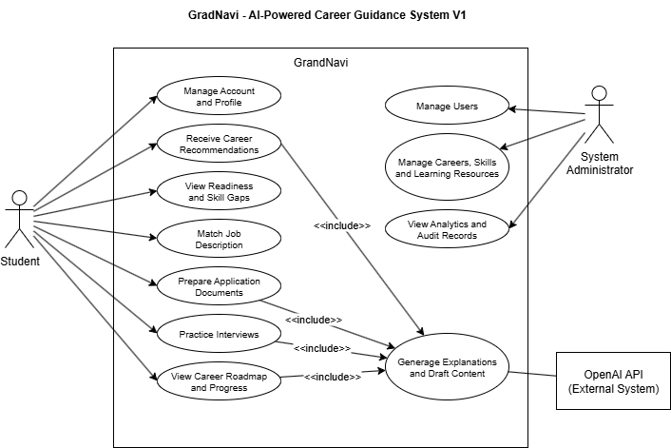
Figure 1. GradNavi High-Level Use Case Diagram

Table 4 GradNavi Student Use Cases

Use Case ID | Student Use Case
UC-01 | Register and authenticate
UC-02 | Manage student profile
UC-03 | Receive career recommendations
UC-04 | View recommendation scores and explanations
UC-05 | Perform skill-gap analysis
UC-06 | View career readiness score
UC-07 | Match a job description
UC-08 | Generate a resume draft
UC-09 | Generate a cover-letter draft
UC-10 | Practise interview questions
UC-11 | Receive learning suggestions
UC-12 | View career path roadmap
UC-13 | Track progress
UC-14 | Review, edit, and save generated content
UC-15 | Delete saved content or request profile deletion

5.3 Main Use Cases
The main use cases describe the high-level interactions between GradNavi and its direct system actors. Students use the system to manage their profiles, receive career guidance, prepare employment materials, and monitor progress. System administrators manage users, career information, skills, learning resources, analytics, and audit records. Detailed system behaviour and acceptance conditions are recorded in the functional requirements and product backlog.

5.4 Context Diagram
Figure 2. GradNavi System Context Diagram

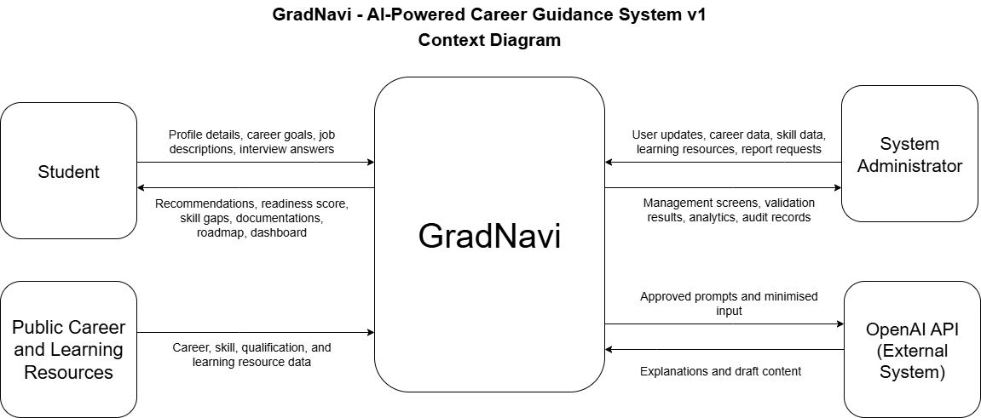

5.4.1 High-Level System Architecture
GradNavi is built on a layered web architecture that isolates the user interface, application logic, data storage, and an external AI service. Separation aids help maintainability, security, testing and controlled integration between system components.
The presentation and frontend layers are a responsive React app hosted on Vercel. Students and administrators use a conventional web browser to access the system. The frontend interacts with the backend Django REST Framework thru secured HTTPS API queries.
The Django backend includes authentication, permissions, business logic, recommendation scoring, skill-gap analysis, job-description matching, career-roadmap functions, document generation, interview preparation, and AI-response validation. The determined numerical suggestion and preparedness scores are based on specified weighted rules. The OpenAI API is intended to provide words and explanations that you may change, not to compute numerical scores.
PostgreSQL stores application records including users, student profiles, skills, recommendations, job-description information, roadmaps, generated documents, and audit information. The backend and PostgreSQL database are hosted on Railway. External OpenAI requests pass through the Django backend so API credentials, input filtering, validation, and response controls stay on the server.

Figure 3. GradNavi High-Level System Architecture
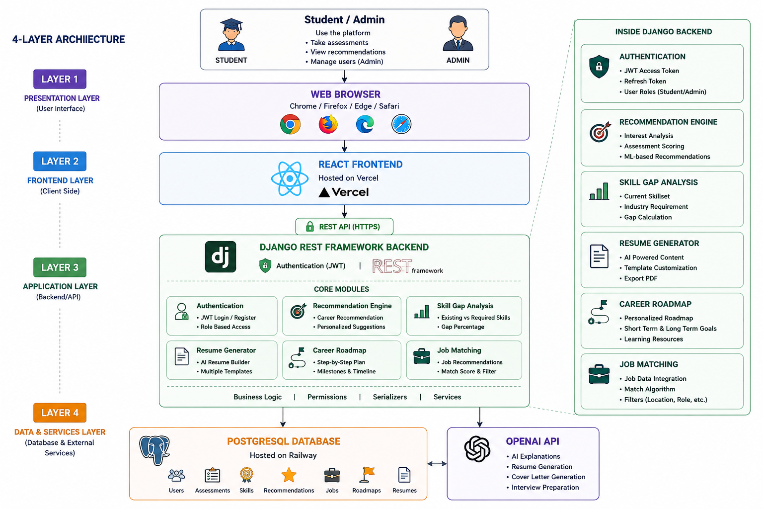

5.4.2 High-Level Data Model
The GradNavi entity relationship diagram shows the primary data entities necessary to support the authorized V1 functionalities, and the relationships between those entities.

The User entity maintains the authentication and role details, and StudentProfile stores career-related information for each student account. StudentSkill records are the skills of students and are linked to Skill reference data. The recommendation records contain the outcome of career recommendations and their justifications, while SkillGap records represent the difference between the current and required levels of skills.

The model also enables employment preparation functions thru JobDescription, Resume, CoverLetter, InterviewSession, and InterviewQuestion records. Roadmap and RoadmapStep entities reflect career development. AuditLog records provide traceability for key system and administrative activities.

This model is the high level relational basis for the PostgreSQL database. Field definitions, constraints, indexes, validation rules and database migrations will be refined during

Figure 4. GradNavi High-Level Entity Relationship Diagram
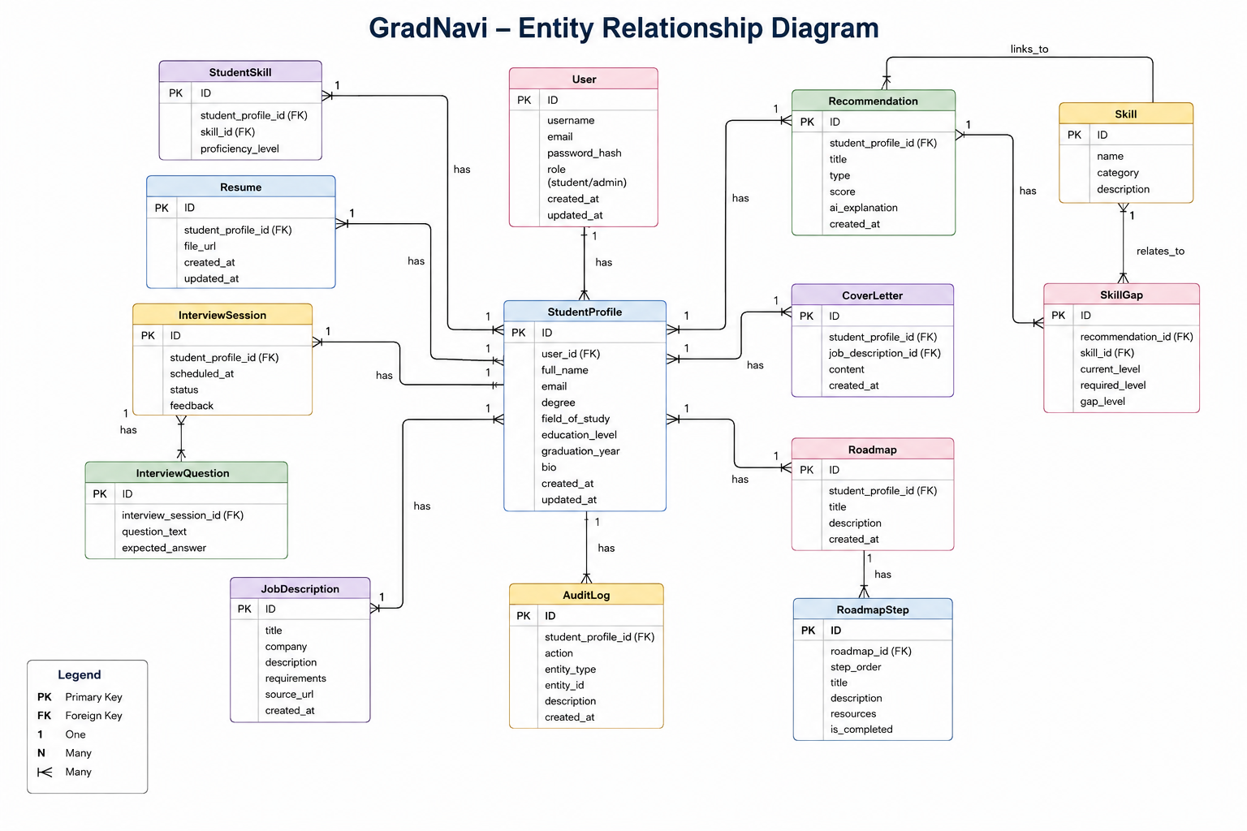
Table 5 GradNavi Context Diagram Data Flows
External Entity | Information Sent to GradNavi | Information Received from GradNavi
Student | Registration details, login credentials, profile information, career goals, job descriptions, interview answers, progress updates, and document edits | Recommendations, scores, explanations, skill gaps, readiness results, matched requirements, documents, feedback, learning suggestions, roadmap steps, and dashboard information
System Administrator | Login details, user updates, career data, skill data, learning resources, corrections, and reporting requests | Management screens, validation results, aggregated reports, audit records, and error messages
OpenAI API | Receives approved prompts and minimised structured input through the backend | Returns structured explanations, document text, interview content, feedback, and roadmap wording
Public Career and Learning Sources | Source information reviewed and entered through administrator processes | No direct automated system output

5.5 Functional Requirements
Table 6 GradNavi Functional Requirements
ID | Functional Requirement | High-Level Statement | Priority
FR-01 | Account registration and authentication | Students will register, sign in, sign out, manage passwords, and recover account access | Must
FR-02 | Student profile management | Students will create and update skills, interests, education, experience, projects, career goals, and personality responses | Must
FR-03 | Career recommendations | GradNavi will produce ranked career recommendations from completed profile information | Must
FR-04 | Scores and explanations | GradNavi will display a match score, contributing factors, and plain-language reasons for each recommendation | Must
FR-05 | Skill-gap analysis | GradNavi will compare student skills with the requirements of a selected career | Must
FR-06 | Career readiness score | GradNavi will calculate readiness through documented weighted criteria | Must
FR-07 | Job-description matching | GradNavi will analyse one pasted job description and display matched, partly met, and missing requirements | Must
FR-08 | Resume builder | GradNavi will generate an editable resume draft from approved profile information | Must
FR-09 | Cover-letter builder | GradNavi will generate an editable cover-letter draft for one selected job description | Must
FR-10 | Interview preparation | GradNavi will provide text-based questions and written feedback on typed answers | Must
FR-11 | Learning suggestions | GradNavi will recommend courses, certifications, and learning resources for identified gaps | Must
FR-12 | Career path roadmap | GradNavi will produce ordered development steps for a selected career | Must
FR-13 | Progress dashboard | GradNavi will display saved careers, readiness results, skill gaps, roadmap progress, and interview history | Should
FR-14 | Basic administration | Authorised administrators will manage users, careers, skills, and learning resources | Must
FR-15 | Administrator analytics | GradNavi will display aggregated statistics such as popular careers and common skill gaps | Should
FR-16 | Generated content review | Students will review and edit generated content before saving | Must
FR-17 | Data deletion | Students will delete saved generated documents and request profile deletion | Must
FR-18 | Audit and error handling | GradNavi will record critical actions and return clear errors when external services fail | Must

5.6 Non-Functional Requirements
Table 7 GradNavi Non-Functional Requirements
ID | Quality Area | High-Level Requirement | Measure
NFR-01 | Usability | Students will complete the main guidance flow without specialist training | Recorded usability tasks and observations
NFR-02 | Responsive design | Core pages will operate on desktop, tablet, and mobile browser widths | Responsive screenshots and device-width checks
NFR-03 | Performance | Normal non-AI API requests will target a response time of two seconds under expected classroom use | API timing records
NFR-04 | AI response handling | AI functions will show loading, timeout, error, and fallback states | Failure-state tests
NFR-05 | Security | Protected functions will require authenticated and authorised access | Authentication and permission tests
NFR-06 | Privacy | GradNavi will collect and process only information required for approved functions | Data-field and request review
NFR-07 | Reliability | Identical structured inputs will return identical weighted scores | Repeatability tests
NFR-08 | Explainability | Scores will display factors, weights, matched areas, and identified gaps | Score breakdown review
NFR-09 | Accessibility | Core forms will use labels, keyboard access, readable contrast, and meaningful errors | Accessibility checklist
NFR-10 | Compatibility | Priority flows will operate in current Chrome, Edge, and Firefox versions | Browser test matrix
NFR-11 | Maintainability | Code will follow modular structure, coding standards, pull-request review, and setup documentation | Repository and review records
NFR-12 | Auditability | Important administrator, security, and data actions will create audit records | Audit-log tests
NFR-13 | Recoverability | The demonstration environment will include database export, restore steps, and a local fallback | Recovery checklist
NFR-14 | Testability | Priority functions will include acceptance tests and automated tests where practical | Test records and reports

5.7 Security and Privacy Requirements
Table 8 GradNavi Security and Privacy Requirements
ID | Requirement
SPR-01 | GradNavi will use secure student and administrator authentication
SPR-02 | Role-based permissions will separate student and administrator functions
SPR-03 | Object-level permission checks will prevent one student from accessing another student’s records
SPR-04 | API keys, passwords, and database credentials will stay in backend environment variables
SPR-05 | AI requests will pass through the Django backend
SPR-06 | The backend will remove unnecessary personal information before sending an external AI request
SPR-07 | Students will review generated content before saving
SPR-08 | Students will delete saved generated documents and request profile deletion
SPR-09 | Important administrator and security actions will create audit records
SPR-10 | The interface will display clear error messages without exposing credentials or private system details
SPR-11 | Protected attributes will not serve as direct recommendation or readiness scoring factors
SPR-12 | Career results will include a statement explaining their advisory purpose

5.8 Data Requirements

Table 9 GradNavi Data Requirements
ID | Data Group | Required Information | Control
DR-01 | User account | Account identifier, role, authentication details, and account status | Restricted access
DR-02 | Student profile | Skills, education, interests, experience, projects, career goals, and personality responses | Student ownership
DR-03 | Career records | Career title, description, required skills, qualifications, and weighted factors | Source and review date
DR-04 | Skill records | Skill name, category, aliases, and related career requirements | Controlled vocabulary
DR-05 | Recommendation results | Ranked careers, scores, contributing factors, explanations, and identified gaps | Linked to owning student
DR-06 | Job-description records | Pasted text, extracted skills, matched requirements, and missing requirements | One description per analysis
DR-07 | Generated documents | Resume drafts, cover-letter drafts, and approved edits | Student review before saving
DR-08 | Interview records | Questions, typed answers, feedback, and completion history | Student ownership
DR-09 | Learning resources | Course, certification, provider, link, related skill, and review date | Source tracking
DR-10 | Career roadmap | Ordered steps, linked skill gaps, learning resources, and progress status | Student ownership
DR-11 | Dashboard records | Saved careers, readiness history, roadmap progress, and interview history | Student ownership
DR-12 | Administrator analytics | Aggregated career selections, common gaps, and system usage summaries | No unnecessary personal detail
DR-13 | Audit records | Actor, action, target, timestamp, and outcome | Administrator access
DR-14 | Test data | Synthetic student profiles, job descriptions, AI responses, and test accounts | No real private information

5.9 Testing Requirements

Table 10 GradNavi Testing Requirements
ID | Testing Requirement
TR-01 | Unit tests will cover scoring, matching, validation, privacy filtering, and utility functions
TR-02 | Frontend component tests will cover forms, validation, navigation, loading states, and errors
TR-03 | API tests will cover authentication, profiles, recommendations, documents, administration, and error responses
TR-04 | Permission tests will verify role access and student record ownership
TR-05 | Integration tests will verify React, Django, PostgreSQL, authentication, audit records, and AI request flows
TR-06 | System tests will cover complete student and administrator journeys
TR-07 | AI tests will cover response structure, invalid output, fallback behaviour, limitation notices, and editable drafts
TR-08 | Usability and accessibility tests will review navigation, task completion, labels, keyboard use, and errors
TR-09 | User acceptance testing will use defined tasks and recorded findings from suitable student participants
TR-10 | Deployment smoke tests will verify login, database connection, API access, AI fallback, audit records, and priority pages
TR-11 | Regression testing will run before release and after major defect corrections
TR-12 | Test evidence will record expected results, outcomes, defects, corrections, and retest status

5.10 AI Requirements
Table 11 GradNavi Artificial Intelligence Requirements
ID | AI Requirement
AIR-01 | Documented weighted rules will calculate recommendation and readiness scores
AIR-02 | Generative AI will support explanations and editable language content rather than numerical scoring
AIR-03 | All OpenAI requests will pass through the Django backend
AIR-04 | The backend will remove personal information not required for each request
AIR-05 | Each AI-supported function will use an approved prompt
AIR-06 | AI responses will follow an expected structure
AIR-07 | GradNavi will validate AI responses before display or storage
AIR-08 | Invalid responses will produce a safe error or approved fallback message
AIR-09 | Resume, cover-letter, interview, explanation, and roadmap outputs will stay editable
AIR-10 | Students will review generated content before saving or using the output
AIR-11 | AI output will include appropriate limitations and advisory wording
AIR-12 | Protected attributes will not serve as direct scoring factors
AIR-13 | Saved test responses will support development when the external AI service is unavailable
AIR-14 | API usage will follow agreed token limits and spending controls

6. Work Decomposition
The GradNavi project uses a hierarchical Work Breakdown Structure to divide the approved scope into manageable phases, tasks, milestones, and deliverables. The final Microsoft Project schedule contains 99 tasks across Project Management, Requirements and Analysis, System Design, four development Sprints, and Finalisation and Release.
Project Management and Requirements and Analysis run in parallel from 23 July to 7 August 2026. System Design runs from 10 to 14 August 2026 and overlaps with the early foundation work in Sprint 1. This structure supports early integration between the frontend, backend, database, authentication, and user-interface components.
The project is organised into the following work packages:
Table 12 GradNavi Work Breakdown Structure Level 1 Work Packages

Level 1 Work Package | Description
Project Management | Project charter, communication planning, GitHub setup, development environment setup, risk management, quality management, resource planning, proposal integration, team meetings, stakeholder communication, and progress monitoring.
Requirements and Analysis | Business need, objectives, scope, stakeholders, functional requirements, non-functional requirements, security and privacy requirements, user stories, acceptance criteria, backlog preparation, and requirements validation.
System Design | Solution architecture, use case diagram, context diagram, database ER diagram, data dictionary, REST API design, wireframes, interface design, and security architecture.
Sprint 1, Foundation and Student Profile | Django and PostgreSQL setup, React setup, authentication, JWT access, login and registration, student profile models, student profile interface, integration, and initial testing.
Sprint 2, Career Recommendations and Skill Gaps | Career and skill data, weighted recommendation engine, recommendation API, readiness scoring, skill-gap analysis, learning suggestions, career roadmap, interfaces, integration, and testing.
Sprint 3, Application Documents and Interview Preparation | AI prompt and safety rules, resume generation, cover-letter generation, interview questions, written feedback, frontend interfaces, integration, and testing.
Sprint 4, Job Matching, Admin and AI Integration | Job-description extraction and matching, OpenAI integration, AI-response validation, administrator functions, dashboard, permissions, audit records, integration, and testing.
Finalisation and Release | Regression testing, security testing, usability review, defect correction, user acceptance testing, deployment, production verification, documentation, report review, and presentation preparation.

Each Level 1 work package is divided into smaller tasks with defined durations, predecessors, resource assignments, and completion milestones. Summary-task dates are calculated from their subtasks. The schedule uses four development Sprints followed by a dedicated Finalisation and Release phase.

Table 13 GradNavi Project Phases and Primary Deliverables

Phase | Primary Deliverables
Project Management | Project management baseline, communication plan, GitHub repository, development environments, risk register, quality plan, resource plan, and monitoring arrangements.
Requirements and Analysis | Approved scope, stakeholder analysis, requirements specification, security controls, user stories, acceptance criteria, and prioritised backlog.
System Design | Solution architecture, use case diagram, context diagram, database ER diagram, data dictionary, REST API specification, wireframes, interface design, and security architecture.
Sprint 1 | Secure authentication, role-based access, student profile, database foundation, frontend foundation, integration, and initial testing.
Sprint 2 | Career recommendation engine, recommendation scores, readiness score, skill-gap analysis, learning suggestions, career roadmap, interfaces, integration, and testing.
Sprint 3 | AI-supported resume drafts, cover-letter drafts, interview questions, written feedback, interfaces, integration, and testing.
Sprint 4 | Job-description matching, OpenAI integration, AI-response validation, administrator tools, administrator dashboard, permissions, audit records, and completed system integration.
Finalisation and Release | Tested and deployed application, acceptance evidence, technical documentation, user guide, final report, GitHub review, and presentation preparation.

This decomposition supports Agile Scrum by organising development into four sequential Sprints. Each Sprint delivers an integrated system increment and ends with review, testing, and acceptance activities.
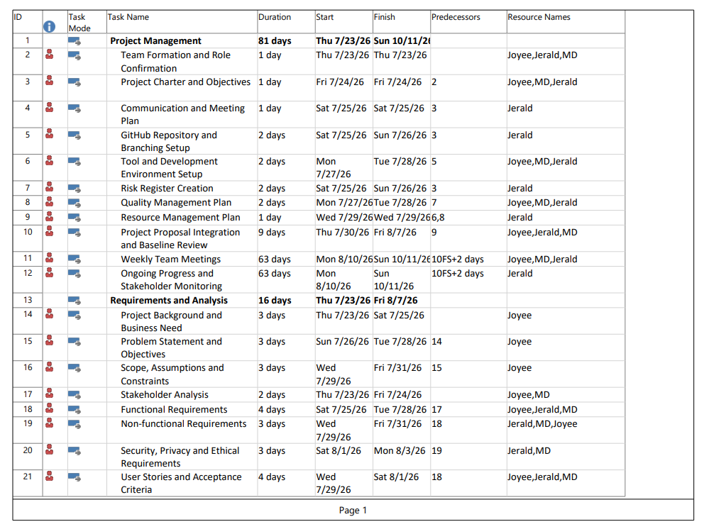
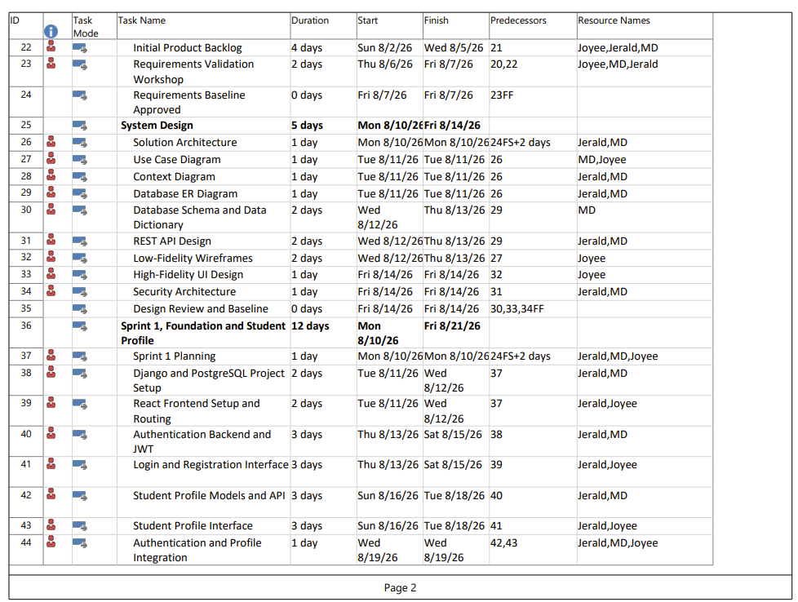
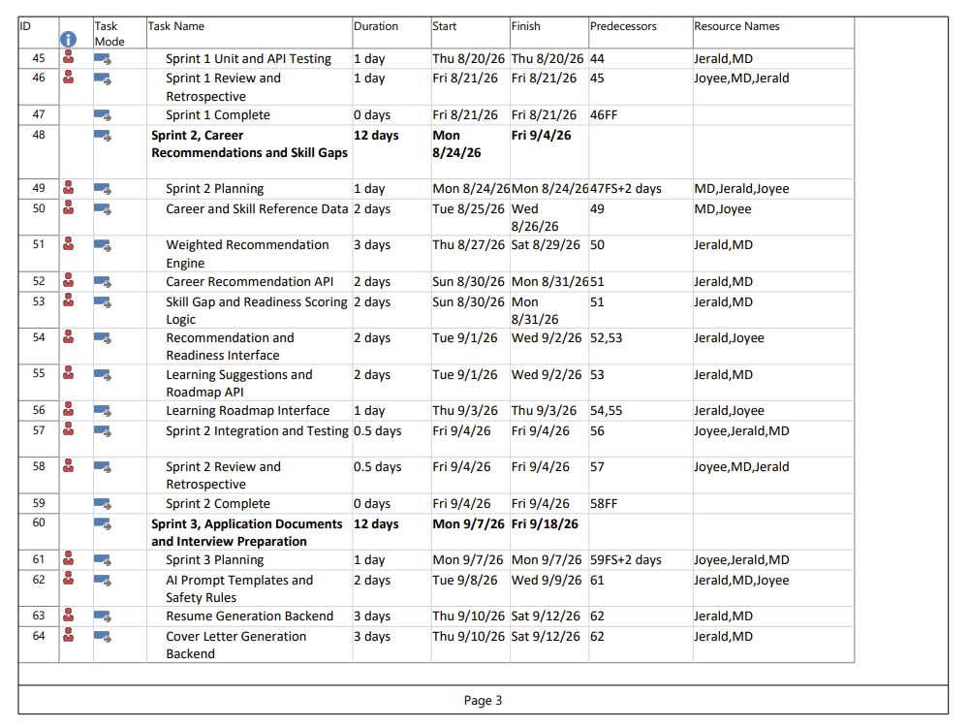
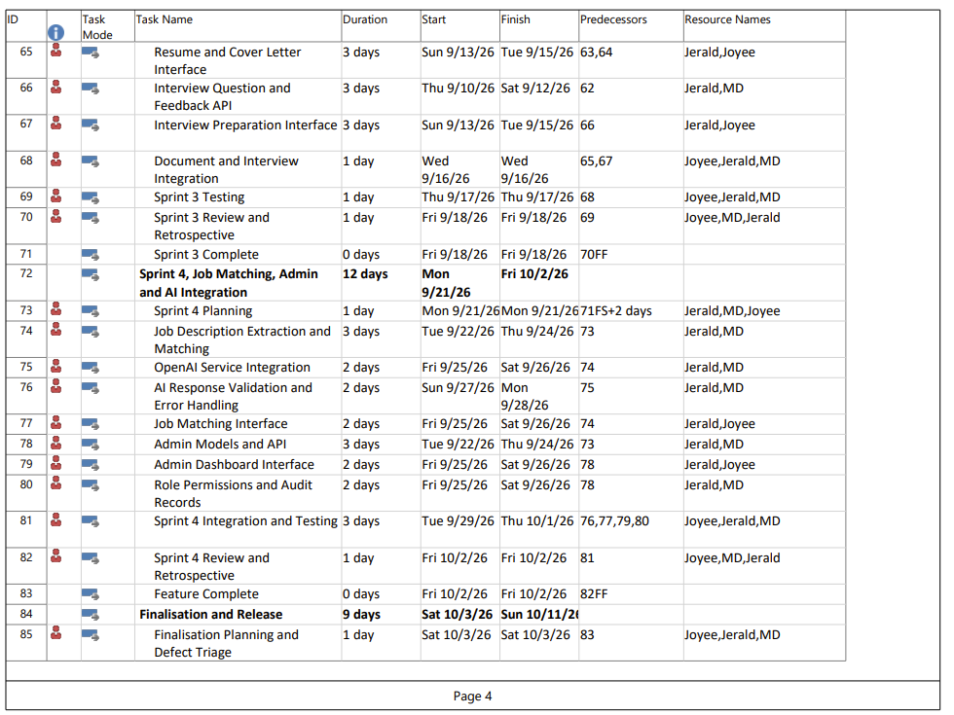
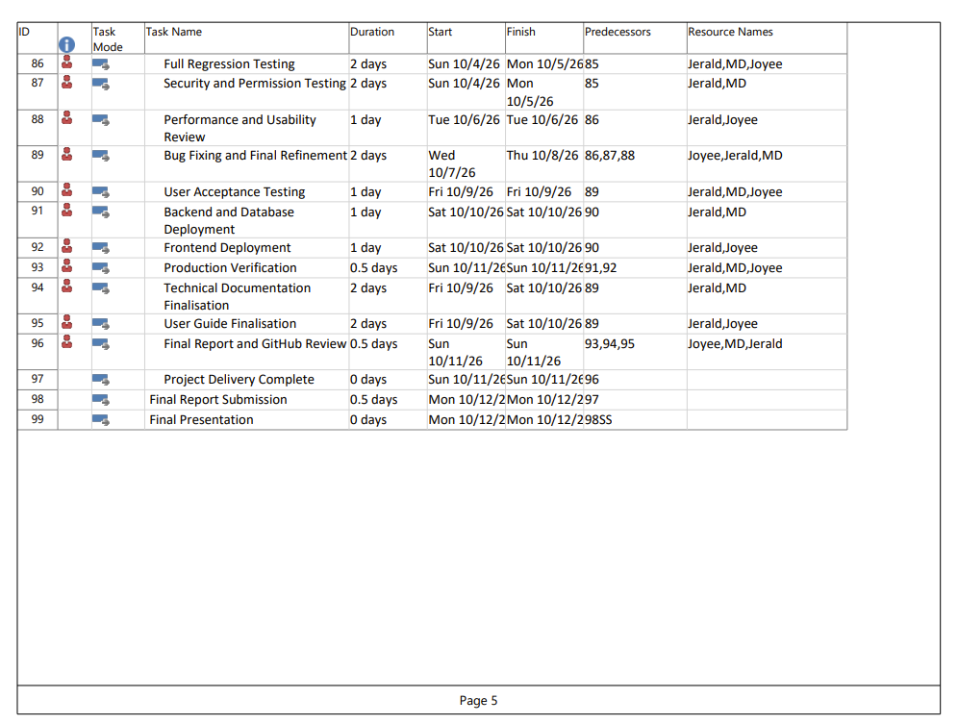

7. Delivery Roadmap
GradNavi will use Scrum through four development Sprints supported by Project Management, Requirements and Analysis, System Design, and a dedicated Finalisation and Release period. The roadmap follows the approved 99-task Microsoft Project schedule. Each Sprint produces an integrated system increment and ends with a review or completion milestone.

7.1 Delivery Approach
The team will use Scrum to divide development into four two-week Sprints. Each Sprint will focus on a defined group of GradNavi functions and end with a Sprint review.
The team will complete the core student journey first. This journey includes secure access, student profile management, career recommendations, readiness scoring, skill-gap analysis, and employment preparation.
Weekly progress reviews will track completed work, blockers, risks, defects, and workload. Work that does not meet the agreed Definition of Done will return to the backlog for further work.

7.2 Project Phases and Sprint Schedule
GradNavi will follow four development Sprints supported by Project Management, Requirements and Analysis, System Design, and a finalisation period. Project Management and Requirements and Analysis run in parallel. System Design overlaps with the beginning of Sprint 1 to support early implementation and integration.

GradNavi will follow four two-week Sprints, supported by an initial planning phase and a finalisation period. Each phase has defined activities and an exit milestone.
Table 14 GradNavi Project Phases and Sprint Schedule

Phase | Dates | Main Work | Exit Milestone
Project Management | 23 July to 7 August 2026 | Confirm team roles, project objectives, communication arrangements, repository setup, development environments, risks, quality controls, resources, and proposal integration. | Project management baseline completed.
Requirements and Analysis | 23 July to 7 August 2026 | Define business needs, scope, stakeholders, functional requirements, non-functional requirements, security controls, user stories, acceptance criteria, and the initial backlog. | Requirements baseline approved.
System Design | 10 August to 14 August 2026 | Complete architecture, use case diagram, context diagram, database ER diagram, data dictionary, API design, wireframes, interface design, and security architecture. | Design baseline approved.
Sprint 1, Foundation and Student Profile | 10 August to 21 August 2026 | Develop project foundations, authentication, JWT access, login, registration, student profile models, profile interface, integration, and initial testing. | Authenticated student-profile flow demonstrated.
Sprint 2, Career Recommendations and Skill Gaps | 24 August to 4 September 2026 | Develop career data, recommendation scoring, readiness scoring, skill-gap analysis, learning suggestions, career roadmap, interfaces, integration, and testing. | Career-analysis flow demonstrated.
Sprint 3, Application Documents and Interview Preparation | 7 September to 18 September 2026 | Prepare AI prompts and safety rules, resume generation, cover-letter generation, interview questions, written feedback, interfaces, integration, and testing. | Application-preparation flow demonstrated.
Sprint 4, Job Matching, Admin and AI Integration | 21 September to 2 October 2026 | Develop job-description matching, OpenAI integration, AI validation, administrator tools, dashboard, permissions, audit records, integration, and testing. | Planned V1 features completed.
Finalisation and Release | 3 October to 11 October 2026 | Run regression, security, usability, and acceptance testing. Correct defects, deploy the system, verify production, complete documentation, review GitHub, and prepare the presentation. | Project delivery completed.
Final Report Submission | 12 October 2026, 12:00 am AEST | Submit the comprehensive group final report. | Assessment 3 submitted.
Final Presentation | 12 October 2026, 9:00 am AEST | Deliver the group presentation and required individual component. | Assessment 4 completed.

7.3 Major Deliverables by Phase
Table 15 GradNavi Major Deliverables by Phase

Phase | Major Deliverables
Project Management | Project management baseline, communication plan, GitHub repository, development environments, risk register, quality plan, resource plan, and monitoring arrangements.
Requirements and Analysis | Approved scope, requirements, security controls, user stories, acceptance criteria, and product backlog.
System Design | Architecture, use case diagram, context diagram, database ER diagram, data dictionary, API design, wireframes, interface design, and security architecture.
Sprint 1 | Authentication, JWT access, role controls, student profile, database foundation, frontend foundation, integration, and initial testing.
Sprint 2 | Career recommendations, weighted scoring, readiness score, skill-gap analysis, learning suggestions, career roadmap, and related interfaces.
Sprint 3 | AI prompts, resume drafts, cover-letter drafts, interview questions, written feedback, interfaces, integration, and testing.
Sprint 4 | Job-description matching, OpenAI integration, AI-response validation, administrator tools, dashboard, permissions, audit records, and completed integration.
Finalisation and Release | Tested and deployed application, acceptance evidence, documentation, final report, GitHub review, and presentation preparation.

7.4 Project Milestones
Table 16 GradNavi Project Milestones

Milestone | Target Date | Completion Measure
Project management and requirements baselines approved | 7 August 2026 | Planning documents, requirements, acceptance criteria, and backlog approved.
Design baseline approved | 14 August 2026 | Architecture, diagrams, database design, APIs, interface designs, and security design approved.
Sprint 1 complete | 21 August 2026 | Secure authentication and student-profile flow demonstrated.
Sprint 2 complete | 4 September 2026 | Career recommendation, readiness, skill-gap, learning, and roadmap flow demonstrated.
Sprint 3 complete | 18 September 2026 | Application-document and interview-preparation flow demonstrated.
Feature complete | 2 October 2026 | Planned V1 development and integration completed.
Project delivery complete | 11 October 2026 | Testing, deployment, documentation, report review, and release evidence completed.
Final report submission | 12 October 2026, 12:00 am AEST | Assessment 3 submitted.
Final presentation | 12 October 2026, 9:00 am AEST | Assessment 4 completed.

7.5 High-Level Delivery Roadmap
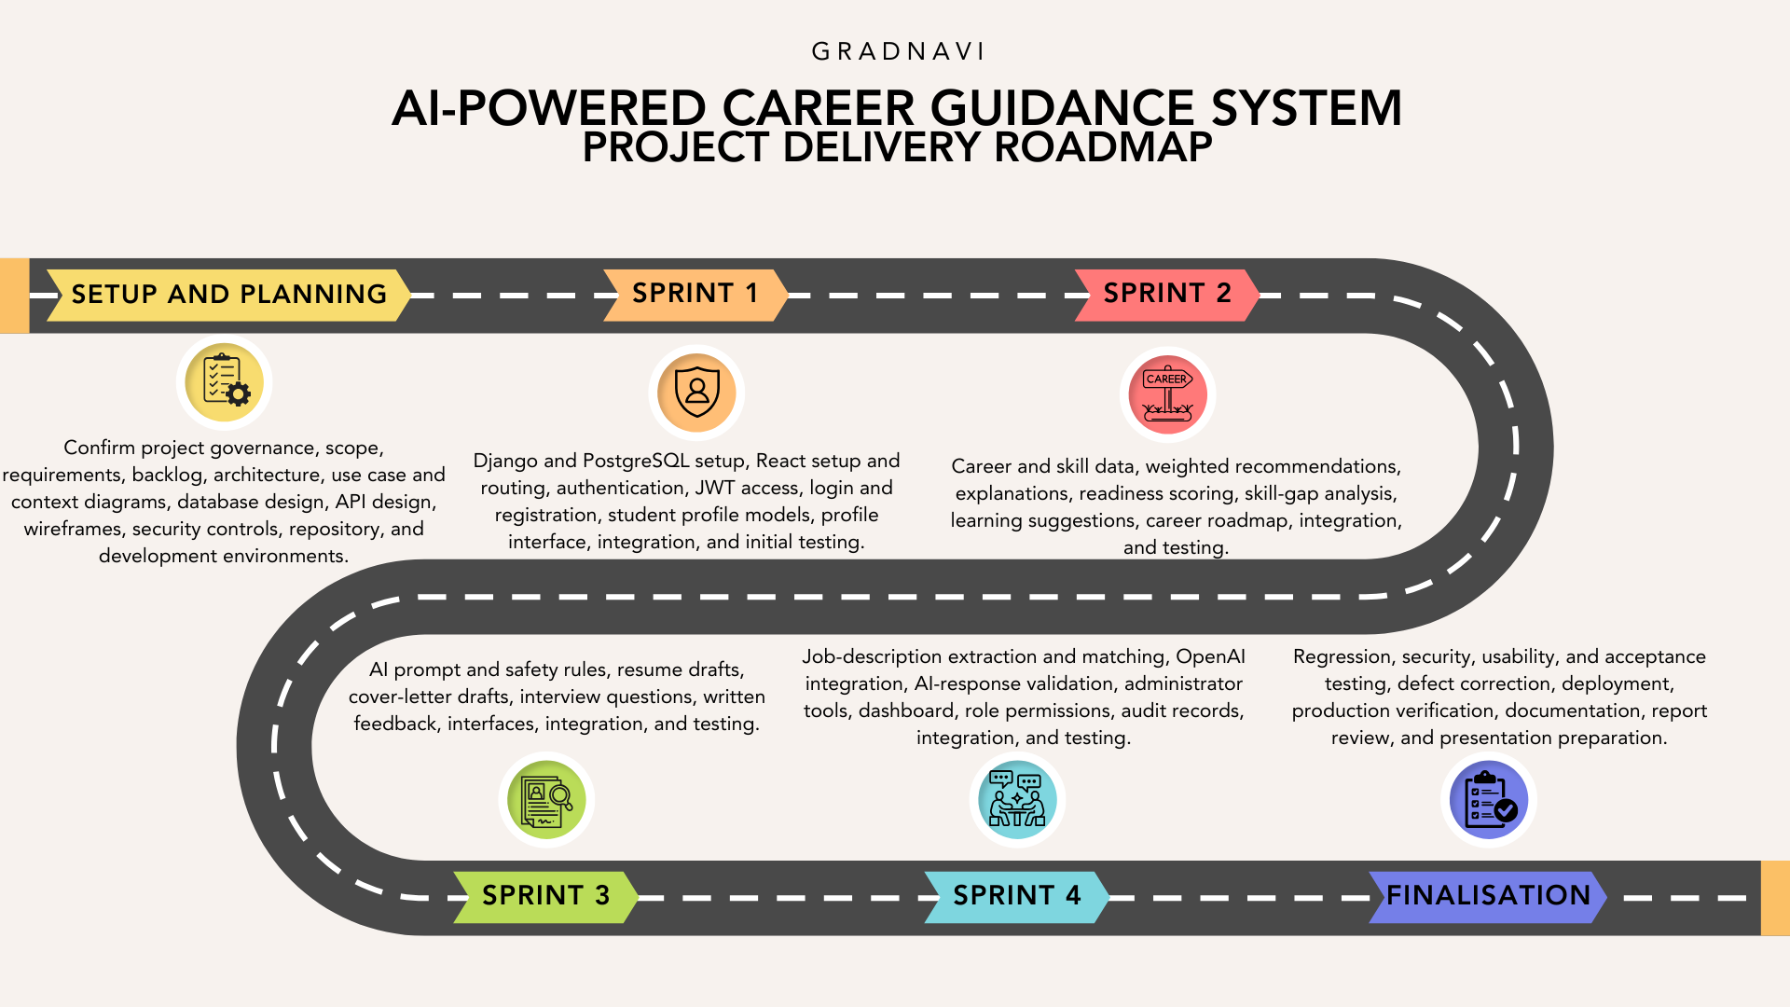
The high-level roadmap summarises how the approved GradNavi scope is distributed across planning, design, four development Sprints, and finalisation.

7.6 Gantt Chart
The detailed Gantt chart presents the 99-task schedule, task durations, dependencies, milestones, and assigned resources used to manage GradNavi delivery.
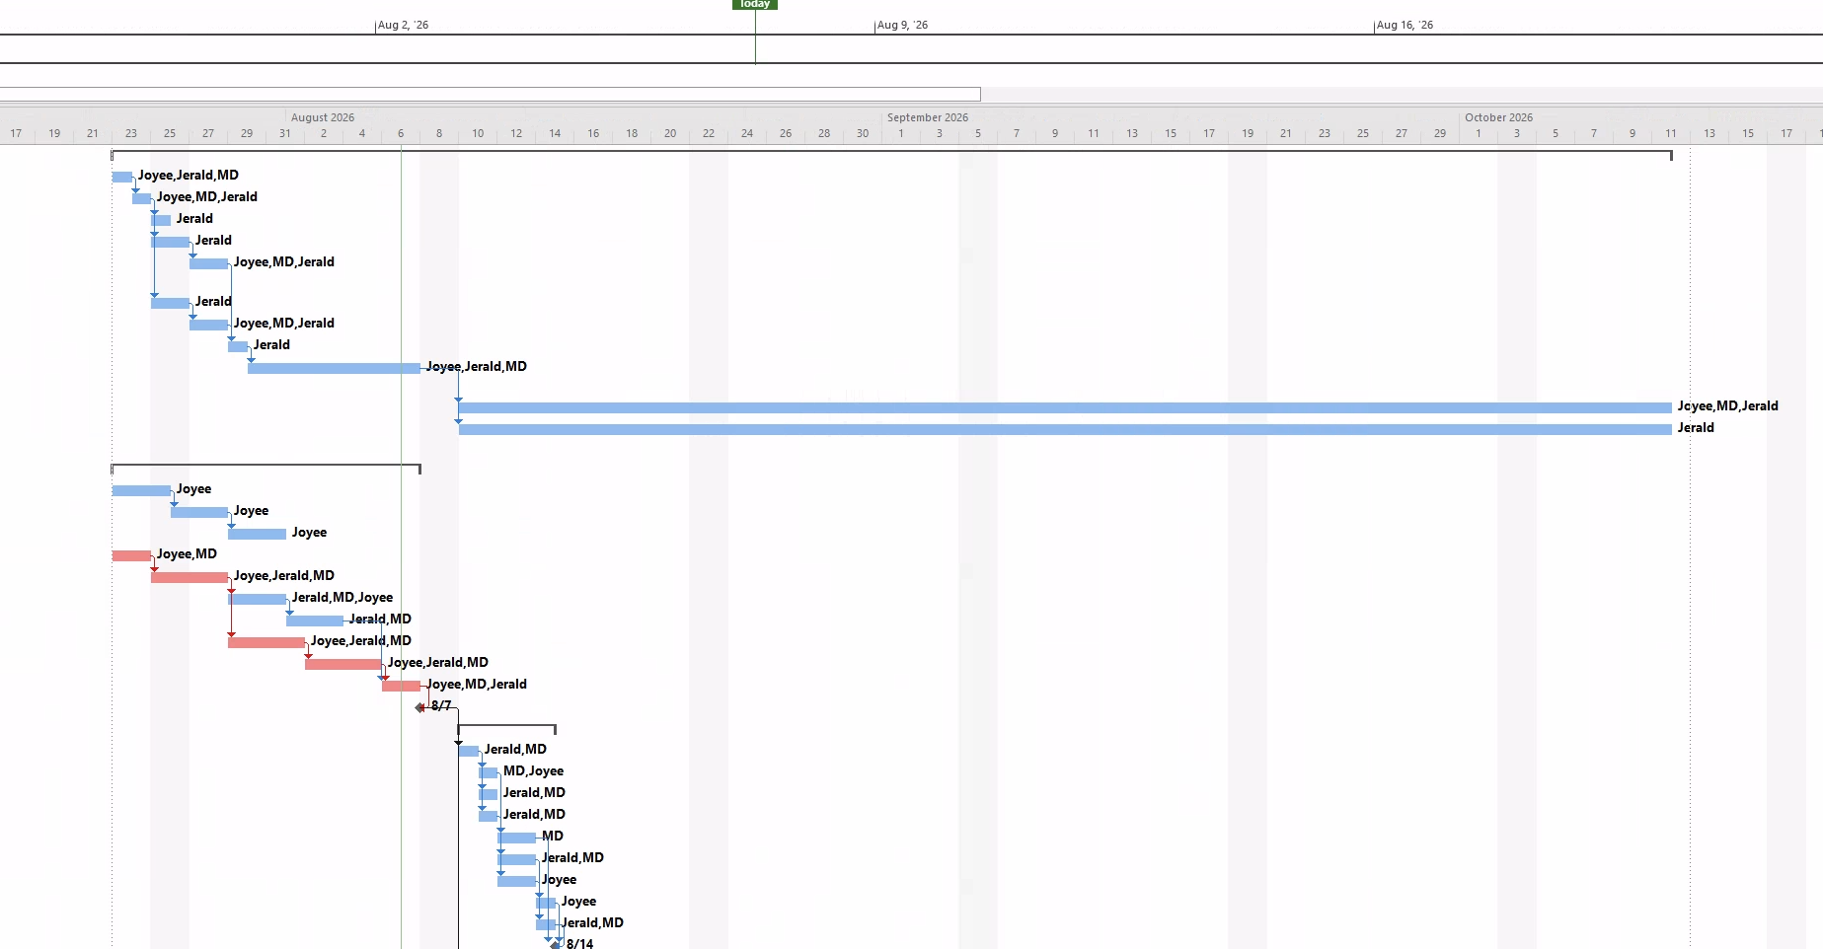

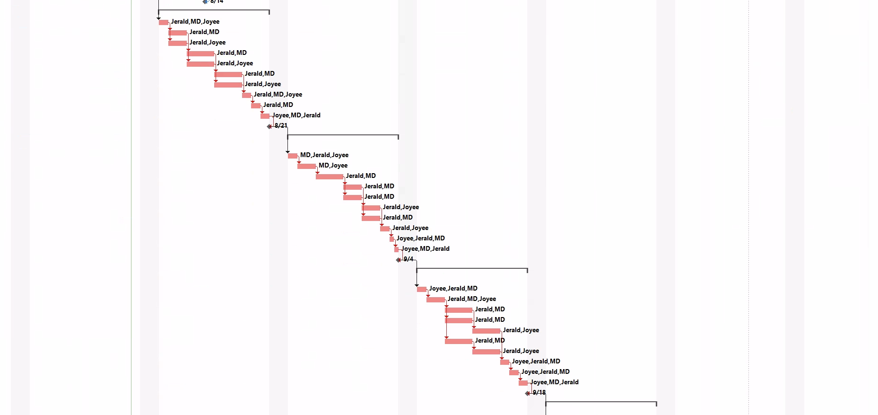

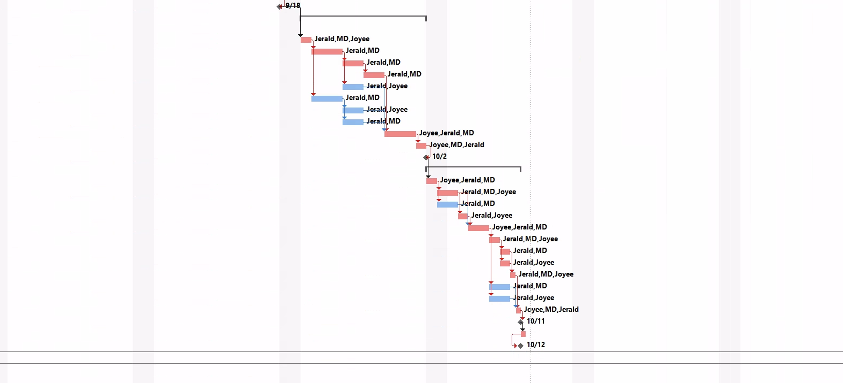

7.7 Schedule Dependencies and Assumptions
The Microsoft Project schedule uses task dependencies to control the sequence of work. Most dependent tasks use Finish-to-Start relationships. Finish-to-Finish relationships are used for completion milestones where the milestone must occur on the same date as its preceding review activity.
Project Management and Requirements and Analysis run in parallel from 23 July to 7 August 2026. System Design and Sprint 1 begin on 10 August 2026. This controlled overlap allows project setup and foundation development to begin while the remaining design outputs are completed.
Frontend, backend, database, and integration tasks run in parallel where separate team members hold technical ownership. Integration and testing tasks depend on the completion of the required frontend and backend components. Each Sprint completion milestone depends on its review and testing activities.
The schedule assumes:
- All three members remain available throughout the term.
- The approved V1 scope stays stable.
- React, Django, PostgreSQL, OpenAI, Vercel, Railway, GitHub, and Microsoft Teams stay accessible.
- Career and skill reference data is available before recommendation development.
- Team members report blockers within 24 hours.
- Work uses the approved flexible seven-day project calendar.
- Any approved scope, resource, or dependency change is recorded in the backlog, risk register, responsibility matrix, and Microsoft Project schedule.
- Add Section 7.8 content

7.8 Roadmap Feasibility
The Microsoft Project schedule uses task dependencies to control the sequence of work. Most dependent tasks use Finish-to-Start relationships. Finish-to-Finish relationships are used for completion milestones where the milestone must occur on the same date as its preceding review activity.
23 July – 7 August 2026 Project Management Requirements Analysis 10 August 2026: System Design and Sprint 1 This managed overlap allows the project set-up and foundation development to commence while the other design outputs are being produced.
Frontend, backend, database, and integration tasks run in parallel where separate team members hold technical ownership. Integration and testing tasks depend on the completion of the required frontend and backend components. Each Sprint completion milestone depends on its review and testing activities.
Feasibility depends on stable scope, continued team participation, early integration, and timely completion of assigned work. Advanced reporting or lower-priority administrator functions will be reduced first if project velocity falls below the approved schedule.

8. Risk Identification and Mitigation Plan

With GradNavi there are project, technical, data, security, artificial intelligence and delivery risks. The risk plan identifies each risk, assesses its likelihood and impact, and assigns a role-based owner. The risk plan also includes preventive and contingency activities. The proposal must outline project hazards and appropriate management solutions.
The plan is in line with the approved scope of the project. GradNavi has safe student profiles, documented weighted scoring, career suggestions, readiness and skill-gap analysis, AI-generated explanations, job-description matching, document generation, interview preparation, administration, testing and deployment.

8.1 Risk Management Approach
Risk assessment will not be a one off effort rather the team will manage risk as the project progresses. Member 1 will have the responsibility for keeping the risk registry. Risk owners will be accountable for monitoring assigned actions and reporting on them in weekly planning meetings and Sprint reviews.

The risk management process follows five steps.
Table 17 GradNavi Risk Management Process
Step | Activity | Expected Output
1. Identify | Identify events that might affect scope, schedule, quality, privacy, security, cost, or delivery. | New risk recorded in the register
2. Assess | Rate likelihood and impact from 1 to 5. | Initial risk score and priority
3. Treat | Select preventive and contingency actions. | Agreed response plan
4. Assign | Assign a role-based owner. | Clear accountability
5. Monitor | Review status, controls, triggers, and evidence. | Updated score, actions, and status

A risk becomes an issue when the event occurs. The team will then record the issue, responsible owner, required action, due date, and resolution evidence.

8.2 Likelihood and Impact Scale
Likelihood measures the chance that a risk will occur during the project.
Table 18 GradNavi Risk Likelihood Scale
Rating | Likelihood Level | Description
1 | Rare | The event is unlikely to occur during the project.
2 | Unlikely | The event might occur, but current controls make it uncommon.
3 | Possible | The event has a reasonable chance of occurring.
4 | Likely | The event is expected to occur unless preventive action succeeds.
5 | Almost Certain | The event is expected to occur or has already started to develop.

Impact measures the effect on project scope, schedule, quality, security, privacy, assessment outcomes, or system operation.
Table 19 GradNavi Risk Impact Scale
Rating | Impact Level | Description
1 | Insignificant | Limited effect. Normal project controls resolve the event.
2 | Minor | Small disruption with little effect on major deliverables.
3 | Moderate | Noticeable rework, delay, quality loss, or reduced functionality.
4 | Major | Serious effect on a Sprint, major feature, integration, or release outcome.
5 | Severe | Threatens submission, core system delivery, personal data, security, or project success.

8.3 Risk Scoring and Priority Levels
The team will calculate each risk score using:
Risk Score = Likelihood × Impact
The existing GradNavi risk method uses five likelihood levels, five impact levels, and four priority bands.
Table 20 GradNavi Risk Scoring and Priority Levels
Priority | Score | Required Response
Low | 1 to 4 | Monitor through normal project controls. Review when conditions change.
Medium | 5 to 9 | Assign an owner, record actions, and review at least weekly.
High | 10 to 14 | Apply preventive action before the affected Sprint. Report status during each review.
Critical | 15 to 25 | Escalate to the full team. Act immediately and consider scope, schedule, or release changes.

The score represents the current exposure before all planned controls take effect. The team will update the score when project conditions or control effectiveness change.

8.4 Risk Matrix
Table 8.4 presents the 5 × 5 likelihood and impact matrix. Risk IDs show the current position of each identified GradNavi risk.
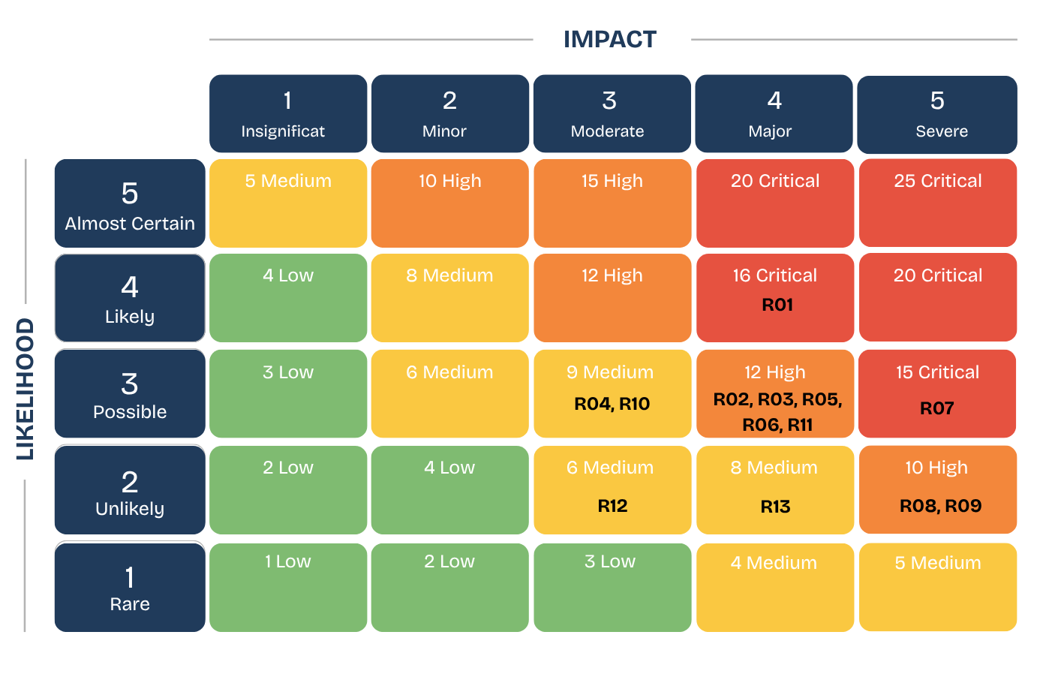
Figure 8.1. GradNavi 5 × 5 Likelihood and Impact Risk Matr

8.5 Risk Register
Table 21 GradNavi Risk Register
ID | Category | Risk Description | Likelihood | Impact | Score and Rating | Preventive Action | Contingency Action | Owner
R01 | Scope and schedule | The approved V1 scope exceeds the capacity of a three-member team within the available term. | 4 | 4 | 16, Critical | Prioritise the core student journey, estimate work before each Sprint, monitor completed work, and reject unapproved scope additions. | Defer the lowest-value supporting feature, starting with advanced administration or reporting, and record the change. | Member 1 and All Members
R02 | Team delivery | Assigned proposal inputs or development tasks are completed later than agreed internal dates. | 3 | 4 | 12, High | Use named owners, internal due dates, GitHub issues, meeting actions, and weekly progress checks. | Reallocate work, reduce non-core tasks, and update the roadmap and responsibility matrix. | Team Leader and All Members
R03 | Requirements | Scope or requirements change after dependent design or development work starts. | 3 | 4 | 12, High | Require each change to record its effect on effort, risk, quality, and schedule before approval. | Move the change to future scope or replace a similar item after team approval. | Member 1 and All Members
R04 | Technical capability | The team needs more time than planned to learn React, Django, PostgreSQL, deployment, or AI integration. | 3 | 3 | 9, Medium | Build small prototypes, maintain setup guides, pair on difficult tasks, and keep the approved stack stable. | Simplify the implementation and assign difficult work to the strongest available member. | Frontend Lead, Backend Lead, and Member 1
R05 | Integration | React, Django, PostgreSQL, authentication, or AI services fail to integrate within the planned Sprint. | 3 | 4 | 12, High | Build a thin end-to-end flow early, agree API formats, integrate continuously, and test each component boundary. | Use mocked AI responses, isolate the failing service, and protect the main student flow. | Member 1 and Backend Lead
R06 | Data quality and coverage | Career, skill, qualification, or learning-resource data is incomplete, outdated, inconsistent, or too limited. | 3 | 4 | 12, High | Record each source, review date, data owner, and correction process. Use a controlled set of careers for the prototype. | Remove unreliable records, correct affected data, and rerun recommendation and matching tests. | All Members
R07 | AI output quality | AI-generated explanations, resumes, cover letters, interview feedback, or roadmap content contains unsupported or misleading guidance. | 3 | 5 | 15, Critical | Use structured prompts, input minimisation, output validation, limitation statements, editable drafts, and student review before saving. | Block invalid output, show a safe error, use approved fallback text, and revise prompts or validation rules. | Backend Lead and All Members
R08 | Fairness and explainability | Recommendation or readiness scoring produces biased, inconsistent, or unclear results. | 2 | 5 | 10, High | Use documented weighted rules, exclude protected attributes from direct scoring, show contributing factors, and test equivalent profiles. | Adjust approved weights, document the reason, and rerun repeatability and fairness tests. | All Members
R09 | Security and privacy | A user accesses another student’s information, personal data is exposed, or credentials are mishandled. | 2 | 5 | 10, High | Apply Django authentication, role-based access, object ownership checks, data minimisation, backend-only secrets, and permission tests. | Disable the affected function, rotate secrets, correct permissions, investigate affected records, and document the incident. | Backend Lead
R10 | Third-party services | OpenAI, Railway, Vercel, GitHub, or another external service becomes unavailable, changes limits, or exceeds the project budget. | 3 | 3 | 9, Medium | Monitor usage, set API limits, use low-cost tiers, create health checks, and prepare saved test responses. | Use mocked AI output, a local demonstration environment, or the last stable deployment. | Member 1 and Backend Lead
R11 | Testing and deployment | Testing begins late, major defects stay unresolved, or deployment fails near the final demonstration. | 3 | 4 | 12, High | Test during every Sprint, define acceptance criteria early, deploy before finalisation, and run smoke and regression tests. | Stop new feature work, focus on critical defects, and use the last stable deployed or local build. | Member 1 and All Members
R12 | User acceptance testing | Too few suitable students participate in user acceptance testing, reducing the quality of usability evidence. | 2 | 3 | 6, Medium | Recruit participants early, prepare short test tasks, and schedule testing before finalisation. | Use additional team-based acceptance checks and clearly state the participant limitation in the report. | Frontend Lead and All Members
R13 | Evidence and final delivery | Meeting records, contribution evidence, test results, documentation, report work, or presentation preparation is incomplete. | 2 | 4 | 8, Medium | Maintain GitHub history, meeting minutes, test evidence, document versions, and weekly evidence checks. | Reconstruct records from Git history and file versions, stop lower-priority work, and focus on assessment evidence. | Member 1 and All Members

8.6 Risk Mitigation Strategies
The team will use the following treatment strategies across the risk register.
Table 22 GradNavi Risk Mitigation Strategies
Strategy | Application to GradNavi
Scope reduction | Protect authentication, profile management, career recommendations, readiness scoring, skill-gap analysis, and the main employment-preparation flow. Defer lower-priority reporting first.
Early integration | Connect the frontend, backend, database, authentication, and AI service during early Sprints.
Stable technical choices | Keep the agreed technology stack fixed unless a documented issue requires change.
Continuous testing | Run unit, API, permission, integration, usability, and regression tests throughout development.
Data governance | Record data sources, review dates, corrections, and the limits of the career dataset.
AI controls | Separate weighted scoring from generative text. Validate AI responses and require user review before saving.
Privacy and security | Minimise personal data, keep secrets on the backend, enforce permissions, and test record ownership.
Service fallback | Prepare mocked AI responses, saved test fixtures, local execution instructions, and a stable demonstration build.
Team governance | Use internal deadlines, meeting actions, issue ownership, task reassignment, and recorded decisions.
Evidence protection | Store code history, test records, minutes, risk updates, and document versions in shared controlled locations.

GradNavi’s design separates documented scoring from AI-generated language. AI processing passes through the backend, unnecessary personal information is removed, and generated text stays editable. These controls reduce scoring, privacy, and unsupported-output risks.

8.7 Risk Monitoring and Review
The team will review risks throughout the project using the schedule below.
Table 23 GradNavi Risk Monitoring and Review Schedule
Review Point | Focus | Participants | Required Record
Weekly planning meeting | New risks, changed ratings, overdue actions, blockers, and owner updates | Team Leader and All Members | Updated risk register and meeting actions
Sprint planning | Risks affecting selected backlog work, capacity, dependencies, and technical readiness | All Members | Sprint risk actions
During development | Security events, integration failures, defects, service outages, and data issues | Relevant Risk Owner | GitHub issue or incident record
Sprint review | Control effectiveness, completed actions, residual exposure, and new delivery risks | All Members | Updated scores and status
Before deployment | Security, privacy, permissions, backups, API limits, and deployment readiness | Member 1, Backend Lead, All Members | Release risk checklist
Finalisation review | Open critical or high risks, fallback demonstration, evidence, report, and presentation readiness | All Members | Final risk acceptance record

Member 1 will maintain the master risk register. Each owner will report progress and supporting evidence. High and Critical risks will appear on the weekly meeting agenda.
The team will update a risk when:
- Its likelihood or impact changes.
- A preventive action is completed.
- A new dependency or scope change appears.
- A risk event occurs and becomes an issue.
- A risk no longer applies.
The team will close a risk only after the risk condition no longer applies, planned actions are complete, and supporting evidence has been recorded. The existing Member 1 plan already requires weekly and Sprint-based risk review, score updates, owners, preventive actions, and contingency actions.

9. Quality Considerations
Quality will form part of requirements, design, implementation, testing, deployment, and documentation. GradNavi will use measurable acceptance criteria and retained evidence for each approved function. The quality plan supports secure access, repeatable scoring, explainable recommendations, controlled AI output, responsive interfaces, reliable data, and documented testing.

9.1 Quality Objectives
Table 24 GradNavi Quality Objectives
Quality Area | Quality Objective
Functional correctness | Each approved requirement and user story meets its acceptance criteria.
Usability | Students complete the main recommendation and employment-preparation flows without specialist training.
Responsive interface | Core pages work across desktop, tablet, and mobile screen sizes.
Performance | Normal non-AI requests respond within the agreed classroom-use target. AI actions display loading, timeout, and fallback states.
Security | Protected functions require authenticated and authorised access.
Privacy | GradNavi stores and sends only information required for the selected function.
Reliable scoring | The same structured inputs produce the same recommendation and readiness scores.
Explainability | Career results show the factors contributing to each score and recommendation.
Accessibility | Forms include labels, keyboard access, readable contrast, and meaningful error messages.
Maintainability | The codebase follows agreed structure, coding conventions, pull-request review, and setup documentation.
Data quality | Career, skill, qualification, and learning-resource records include sources and review information.
AI response quality | AI output follows the approved structure, passes validation, and appears as an editable draft.
Recoverability | The demonstration environment has documented data export, restoration, and fallback steps.

9.2 Quality Standards and Measures
Table 25 GradNavi Quality Standards and Measures
Quality Standard | Measure | Evidence
Requirements compliance | Approved requirements meet defined acceptance criteria. | Requirements traceability table, test cases, and Sprint review records
Functional correctness | Priority student and administrator flows complete without Critical defects. | System test results and defect records
Responsive design | Core pages display and operate across approved desktop, tablet, and mobile widths. | Responsive screenshots and browser checks
Performance | Non-AI API requests meet the agreed response target under classroom use. | Timing records and API test results
AI response handling | AI actions show loading, timeout, error, and fallback states. | Interface tests and recorded failure cases
Authentication | Protected functions reject unauthenticated access. | Authentication tests
Authorisation | Students access only their own records. Administrator access follows approved role permissions. | Role and object-permission tests
Privacy | External AI requests exclude unnecessary personal information. | Request inspection and privacy checklist
Scoring reliability | Fixed test profiles return fixed expected scores. | Automated repeatability tests
Explainability | Results show factors, weights, gaps, and plain-language explanations. | Score breakdowns and interface review
Data quality | Reference data includes source, review date, and correction status. | Data-source register and validation records
AI validity | Invalid or unsupported output is blocked before display or storage. | Schema tests, prompt cases, and fallback tests
Accessibility | Core pages support labels, keyboard use, readable contrast, and meaningful errors. | Accessibility checklist and task observations
Documentation | Setup, API, testing, deployment, and user guidance stay current. | Document review record

9.3 Quality Assurance Activities
Quality assurance focuses on preventing defects before release.
Table 26 GradNavi Quality Assurance Activities
Quality Assurance Activity | Required Practice | Timing
Requirements review | Review requirements for clarity, feasibility, testability, and acceptance criteria. | Before backlog approval
Scope review | Check alignment between objectives, scope, requirements, roadmap, and resources. | Before Sprint 1 and after approved changes
Architecture review | Review frontend, backend, database, authentication, AI boundaries, and deployment structure. | Before dependent development
Data-design review | Review entities, relationships, validation rules, source records, and sensitive fields. | Before database expansion
Interface review | Review navigation, forms, error messages, responsiveness, and accessibility. | Before implementation and during each Sprint
Branch and pull-request control | Develop each feature in an approved branch and review changes before merging. | For each code change
Dependency control | Record package versions and maintain reproducible setup instructions. | During setup and package updates
Continuous testing | Run automated and recorded manual tests throughout development. | During every Sprint
Defect management | Record severity, owner, status, evidence, correction, and retest result. | From Sprint 1 onward
Sprint review | Demonstrate completed work and accept only work meeting the Definition of Done. | End of each Sprint
AI review | Review prompts, structured outputs, unsupported claims, privacy filtering, and failure behaviour. | During AI feature development
Release review | Review regression, security, privacy, deployment, recovery, documentation, and demonstration readiness. | During finalisation
Document review | Check terminology, references, formatting, versions, and consistency. | Before submission

9.4 Testing Strategy
Table 27 GradNavi Testing Strategy
Test Level | Scope | Tool or Method | Exit Evidence
Unit testing | Scoring, matching, validation, privacy filtering, and utility functions | Pytest and Django tests | Expected values, edge cases, and error cases pass
Frontend component testing | Forms, validation, navigation, loading states, errors, and user interactions | React Testing Library | Required states and interactions pass
API testing | Authentication, profiles, recommendations, documents, administration, permissions, validation, and errors | Django tests and Postman | Status codes, schemas, validation, and access rules pass
Integration testing | React, Django, PostgreSQL, authentication, audit records, and AI request flow | Automated tests and recorded manual tests | Data moves correctly and failure states work
System testing | Complete student and administrator journeys | Deployed-environment test cases | Priority flows pass without Critical defects
Security and privacy testing | Role access, object ownership, secrets, AI input minimisation, and data deletion | Permission tests and security checklist | No unauthorised access, exposed secrets, or unnecessary AI input
AI quality testing | Response structure, unsupported claims, fallback handling, editable drafts, and limitation text | Prompt cases and validation tests | Invalid output is blocked and valid output follows the approved structure
Usability testing | Navigation, clarity, errors, responsiveness, and task completion | Student tasks and observation checklist | Major barriers are corrected and findings recorded
Accessibility testing | Labels, keyboard use, contrast, validation messages, and responsive layout | Accessibility checklist | Core barriers are corrected
User acceptance testing | Approved V1 outcomes and final demonstration flow | Student participant review | Core V1 receives release acceptance and sample limits are recorded
Deployment smoke testing | Login, database connection, API access, AI fallback, audit records, and core pages | Vercel and Railway build checks | Critical checks pass after deployment

9.5 AI and Data Quality Controls
GradNavi separates deterministic scoring from AI-generated language. Documented weighted rules calculate recommendation and readiness scores. AI services explain results and generate editable text but do not determine the numerical score.

Table 28 GradNavi AI and Data Quality Controls
Control Area | Required Control | Evidence
Scoring separation | Use documented weighted rules for recommendation and readiness scores. | Scoring documentation and unit tests
Repeatability | Return the same score for the same structured input. | Fixed-profile repeatability tests
Backend AI processing | Send AI requests through the Django backend only. | Architecture review and request inspection
Secret protection | Store the AI API key in backend environment variables. | Secret-management review
Data minimisation | Remove personal information not required for the AI request. | Privacy-filter tests and request samples
Prompt control | Use approved prompts for each AI-supported function. | Prompt register and version history
Structured output | Require expected fields and formats from AI responses. | Schema-validation tests
Response validation | Check AI output before display or storage. | Invalid-output and fallback tests
Unsupported claims | Reject or flag unsupported career statements. | Prompt cases and manual review
Editable output | Present resumes, cover letters, explanations, roadmaps, and interview feedback as drafts. | Interface review
User review | Require student review before using or saving generated material. | User-flow test
Advisory limitation | State that career results support decisions and do not replace professional careers advice. | Limitation text and acknowledgement
Fairness | Exclude protected attributes from direct scoring factors. | Equivalent-profile and fairness tests
Source tracking | Record the source and review date for career, skill, qualification, and learning data. | Data-source register
Data correction | Support correction or removal of inaccurate reference records. | Administrator tests and audit records
Data coverage | State the number and limits of careers represented in the prototype. | Scope record and final report

9.6 Definition of Done
A feature is complete when all conditions below are met.
- The approved acceptance criteria are met.
- Code has passed review and merged through the agreed GitHub workflow.
- Automated tests or recorded manual tests pass.
- No unresolved Critical defect affects the feature.
- Authentication, permissions, privacy, validation, audit requirements, and error handling have been checked.
- AI-supported output passes structure, limitation, privacy, and fallback checks.
- Relevant technical and user documentation has been updated.
- The feature works inside the integrated application.
- The team accepts the result during the Sprint review.
These conditions align with the current Member 1 quality plan and testing approach.

9.7 Release and Acceptance Criteria
Table 29 GradNavi Release and Acceptance Criteria
Release Criterion | Required Evidence
Priority flows pass | System and acceptance test results for student and administrator journeys
Critical defects resolved | Defect register with no open Critical release defect
Security accepted | Authentication, role, object-permission, and secret-management test results
Privacy accepted | Data-field review, AI input inspection, access tests, and deletion checks
AI controls accepted | Prompt tests, schema validation, unsupported-claim checks, and fallback evidence
Scoring accepted | Repeatability tests and approved score documentation
Data accepted | Source register, review dates, validation results, and correction records
Usability accepted | Student task results and corrected major barriers
Deployment accepted | Vercel, Railway, database, API, and smoke-test evidence
Recovery accepted | Database export, restoration, and local fallback instructions
Documentation complete | Final report, setup guide, test evidence, user guide, and contribution records
Demonstration ready | Stable deployed build, fallback path, and completed presentation rehearsal

10. Team Structure, Roles and Responsibilities Matrix
GradNavi has a three-member cross-functional development team. Each member has a defined technical role and proposal responsibility. The team shares requirements review, integration, testing, documentation, and final delivery.
A RACI matrix provides the best format for this section. It separates accountability from hands-on responsibility and prevents unclear ownership. The assessment requires clear team roles, fair task allocation, leadership rotation, meeting arrangements, and a responsibilities matrix.

10.1 Team Structure
Table 30 GradNavi Team Structure
Team Member | Student ID | Primary Role | Main Focus
Jerald Christopher Yalung Bucud | 12301099 | Full-Stack Developer | System integration, frontend and backend support, project planning, quality, risk, deployment, and technical coordination
Joyee Chakraborty | 12286715 | Frontend Lead | User interface, user experience, responsive design, accessibility, frontend validation, dashboards, and frontend testing
Md Enamul Haque | 12280315 | Backend Lead | Django APIs, PostgreSQL, business logic, authentication, permissions, AI integration, scoring, matching, and backend testing

The structure gives each technical area a clear lead while preserving shared development and review. GradNavi requires a responsive React interface, Django backend, PostgreSQL database, secure access, AI processing, testing, and deployment.

10.2 Team Member Roles and Responsibilities
Table 31 GradNavi Team Member Roles and Responsibilities
Team Member | Proposal Responsibilities | Technical Ownership | Supporting Responsibilities
Jerald Christopher Yalung Bucud | Delivery roadmap, Gantt chart, risk plan, quality considerations, required tools, and resources | Full-stack integration, architecture coordination, authentication and profile integration, deployment, GitHub workflow, Microsoft Project schedule, and release preparation | Support frontend and backend development, review pull requests, maintain project evidence, and coordinate testing
Joyee Chakraborty | Project background, justification, problem statement, objectives, innovation, scope, assumptions, and constraints | React interface, Material UI components, responsive layouts, accessibility, forms, dashboards, client-side validation, and frontend component testing | Support requirements review, usability testing, design consistency, documentation, and presentation preparation
Md Enamul Haque | High-level requirements, WBS, backlog structure, responsibility matrix, and task-lead allocation | Django REST APIs, PostgreSQL models and migrations, scoring logic, job-description matching, AI service integration, role permissions, audit records, and backend testing | Support architecture, integration, deployment preparation, technical documentation, and system testing
All Members | Final proposal review and contribution declaration | Integration, testing, defect review, data review, ethical AI review, and release approval | Meetings, Sprint reviews, documentation, presentation, and contribution evidence

10.3 Responsibilities Matrix
RACI means:
Table 32 GradNavi RACI Code Definitions
Code | Meaning
R | Responsible for completing the work
A | Accountable for the final result and approval
C | Consulted before decisions or changes
I | Informed about progress and outcomes

Each activity should have one clear accountable member. Several members might share responsibility where frontend, backend, and integration work overlap.

Table 33 GradNavi RACI Responsibilities Matrix
Deliverable or Activity | Jerald | Joyee | Md Enamul
Project background, objectives, innovation, and scope | C | A/R | C
High-level requirements | R | R | A/R
WBS and backlog structure | C | C | A/R
Delivery roadmap and Gantt chart | A/R | C | C
Risk management plan | A/R | C | C
Quality management plan | A/R | R | R
Tools and resource planning | A/R | C | C
System architecture and integration | A/R | C | R
Frontend interface and user experience | R | A/R | C
Backend APIs and business logic | R | C | A/R
PostgreSQL database and migrations | R | I | A/R
Authentication, permissions, and security | R | C | A/R
Recommendation scoring and skill-gap logic | R | C | A/R
Job-description matching | R | C | A/R
AI integration and response validation | R | C | A/R
Student profile interface | R | A/R | R
Resume, cover-letter, and interview interface | C | A/R | R
Administration interface and reports | R | A/R | R
Frontend component testing | R | A/R | C
Backend and API testing | R | C | A/R
Integration and system testing | A/R | R | R
Deployment and release preparation | A/R | R | R
Final report integration | A/R | R | R
Final presentation | R | R | A/R

The matrix separates technical ownership while keeping testing, integration, and final delivery shared. This supports the assessment requirement for clear role allocation and team accountability.

10.4 Shared Responsibilities
Table 34 GradNavi Shared Team Responsibilities
Shared Area | Team Responsibility
Requirements review | Review and approve functional, non-functional, security, data, testing, and AI requirements
Architecture decisions | Review major decisions affecting the frontend, backend, database, deployment, and AI service
Backlog review | Confirm priorities, estimates, dependencies, and Sprint assignments
Code review | Review pull requests before merging changes into the shared branch
System integration | Connect React, Django, PostgreSQL, authentication, and AI-supported functions
Testing | Perform unit, component, API, permission, integration, system, usability, and acceptance testing
Data quality | Review career, skill, qualification, learning-resource, and synthetic test data
Ethical AI | Review privacy filtering, scoring fairness, generated text, limitations, and fallback behaviour
Documentation | Maintain setup instructions, meeting minutes, test evidence, technical records, and report sections
Release approval | Review the deployed system, defects, evidence, fallback process, and demonstration readiness
Presentation | Prepare slides, rehearse the demonstration, and answer project questions
Contribution evidence | Maintain GitHub activity, task records, meeting actions, document versions, and test evidence

10.5 Team Leadership Rotation
The team leader role will rotate across three equal 21-day periods. The final six-day release period will use joint coordination. This structure gives every member equal leadership time, as required by the team management guidelines.
Table 35 GradNavi Team Leadership Rotation

Leadership Period | Dates | Team Leader | Main Leadership Focus
Period 1 | 23 July to 12 August 2026 | Jerald Christopher Yalung Bucud | Project setup, planning, requirements coordination, roadmap control, risk management, meeting records, and early system integration.
Period 2 | 13 August to 2 September 2026 | Joyee Chakraborty | Sprint 1 completion, Sprint 2 coordination, frontend progress, usability, design consistency, blockers, and backlog review.
Period 3 | 3 September to 23 September 2026 | Md Enamul Haque | Sprint 3 coordination, backend progress, AI functions, testing progress, technical documentation, and Sprint 4 preparation.
Joint Finalisation | 24 September to 12 October 2026 | All Members | Sprint 4 completion, integration, testing, deployment, report completion, presentation rehearsal, and submission readiness.

The active team leader will:
- Coordinate the weekly meeting.
- Prepare the meeting agenda.
- Record minutes, decisions, and action items.
- Confirm task owners and due dates.
- Track blockers and overdue work.
- Update the backlog and shared project records.
- Escalate unresolved risks to the full team.

10.6 Communication and Meeting Arrangements
Table 36 GradNavi Communication and Meeting Arrangements
Communication Activity | Schedule | Platform | Purpose | Record Owner
Weekly team meeting | Every Monday at 9:00 am | Microsoft Teams | Review progress, assign work, discuss blockers, update risks, and confirm weekly priorities | Current Team Leader
Sprint planning | At the beginning of each Sprint | Microsoft Teams and GitHub Projects | Confirm the Sprint goal, selected backlog items, estimates, dependencies, and owners | Current Team Leader
Progress updates | Before the weekly meeting and when a blocker occurs | Microsoft Teams and GitHub | Report completed work, planned work, and blockers | Each Member
Sprint review | At the end of each Sprint | Microsoft Teams | Demonstrate completed functions and confirm acceptance against the Definition of Done | Current Team Leader
Sprint retrospective | After each Sprint review | Microsoft Teams | Discuss team process, workload, communication, and improvements | Current Team Leader
Technical discussions | As required | Microsoft Teams and GitHub | Resolve architecture, API, database, interface, and integration decisions | Relevant Technical Lead
Urgent blocker notice | Within 24 hours of identifying the blocker | Microsoft Teams | Request support before the blocker affects the Sprint schedule | Affected Member
Document review | Before each assessment submission | Shared document and Microsoft Teams | Check content, references, formatting, consistency, and contribution records | All Members

Meeting minutes will record:
- Date and Attendance
- Current Blockers
- Decisions made
- Assigned actions
- Task owner
- Due date
- Risk and schedule changes
- Items for the next meeting

Microsoft Teams will hold meeting links, discussions, decisions, action items, and shared file links. GitHub Issues and Projects will hold technical tasks, priorities, ownership, and progress records. The existing resource plan already identifies Microsoft Teams as the project communication platform.

10.7 Workload and Collaboration Management
The team will allocate work using task complexity, estimated effort, technical responsibility, member availability, and Sprint priority. Task allocation will remain fair and open to team review.
Table 37 GradNavi Workload and Collaboration Management
Management Area | Agreed Approach
Task estimation | Estimate tasks through hours or story points before adding them to a Sprint
Fair allocation | Review assigned effort across all three members before Sprint approval
Technical ownership | Assign the relevant lead as accountable while allowing support from other members
Cross-functional work | Divide connected tasks into frontend, backend, integration, and testing responsibilities
Pairing | Pair members on difficult, unfamiliar, or blocked tasks
Workload review | Review current and upcoming workload during every Monday meeting
Over-allocation | Move tasks, reduce scope, or add support when one member has excessive work
Under-allocation | Assign testing, documentation, review, data preparation, or integration support
Blockers | Report blockers within 24 hours and assign a resolution action
Missed deadlines | Review the cause, assign support, revise dates, and record the change
Role changes | Record changes in meeting minutes, the responsibility matrix, and the backlog
Disagreement resolution | Discuss the issue as a team, compare project evidence, and record the agreed decision
Non-contribution | Record missed actions and attempts to resolve the issue before escalation
Contribution evidence | Retain commits, issues, pull requests, meeting records, tests, and document versions

The team will first resolve minor collaboration issues internally. Workload adjustments will protect the core student journey and prevent one member from carrying an unreasonable share of the project. The assessment guidelines require democratic task allocation, realistic effort estimates, and action when workloads become uneven.

11. Identification Of Tasks Leads For Each Major Deliverable
Task leads provide clear ownership for major project outputs. Each task lead coordinates the work, monitors progress, manages dependencies, and prepares the deliverable for team review.
The final task-lead allocation must align with the approved WBS, backlog, technical responsibilities, and workload estimates. The assessment requires clear task leads for major project deliverables.

11.1 Task Lead Allocation Method
The team will allocate task leads using the following criteria.
Table 38 GradNavi Task Lead Allocation Criteria
Allocation Criterion | Application
Technical role | Frontend work will normally be led by the Frontend Lead. Backend work will normally be led by the Backend Lead. Integration and planning work will normally be led by the Full-Stack Developer.
Knowledge and skills | The member with the strongest relevant knowledge will lead the deliverable.
Proposal responsibility | The member assigned to prepare a proposal section will lead its completion and integration.
Workload | The team will review current and planned workload before confirming a task lead.
Task complexity | Complex deliverables will include supporting members and additional review.
Dependencies | The lead will coordinate inputs required from other members before work begins.
Accountability | Each major deliverable will have one named task lead.
Team review | All major deliverables will receive team review before approval.

The task lead will:
- Confirm the deliverable scope.
- Break the deliverable into tasks.
- Coordinate supporting members.
- Track progress and blockers.
- Maintain evidence of completed work.
- Present the output for team review.
- Record approved changes.

11.2 Major Deliverables and Task Leads
Table 38A GradNavi Major Deliverables and Task Leads
Major Deliverable | Task Lead | Supporting Members | Approval Responsibility
Project background, objectives, innovation, and scope | Joyee Chakraborty | Jerald and MD | All Members
High-level requirements | Md Enamul Haque | Jerald and Joyee | All Members
WBS and product backlog | Md Enamul Haque | Jerald and Joyee | All Members
Delivery roadmap and Gantt chart | Jerald Christopher Yalung Bucud | Joyee and MD | All Members
Risk management plan | Jerald Christopher Yalung Bucud | Joyee and MD | All Members
Quality management plan | Jerald Christopher Yalung Bucud | Joyee and MD | All Members
Tools and resource planning | Jerald Christopher Yalung Bucud | Joyee and MD | All Members
System architecture and integration | Jerald Christopher Yalung Bucud | Joyee and MD | All Members
Frontend interface and user experience | Joyee Chakraborty | Jerald and MD | All Members
Backend APIs, database, authentication, and security | Md Enamul Haque | Jerald and Joyee | All Members
AI scoring, matching, and response validation | Md Enamul Haque | Jerald and Joyee | All Members
Testing and release preparation | Jerald Christopher Yalung Bucud | Joyee and MD | All Members
Final report integration | Jerald Christopher Yalung Bucud | Joyee and MD | All Members
Final presentation | Md Enamul Haque | Jerald and Joyee | All Members

11.3 Shared Deliverables
Table 39 GradNavi Shared Deliverables and Coordination Responsibilities
Shared Deliverable | Shared Responsibility | Coordination
High-level requirements review | Review functional, non-functional, stakeholder, security, data, testing, and AI requirements | Current Team Leader
Architecture review | Review frontend, backend, database, authentication, AI, and deployment decisions | Full-Stack Developer and Backend Lead
Backlog review | Review priorities, estimates, dependencies, and Sprint assignments | Current Team Leader
System integration | Connect React, Django, PostgreSQL, authentication, and AI-supported functions | Full-Stack Developer
Data quality review | Review career, skill, qualification, learning-resource, and test data | All Members
Ethical AI review | Review privacy controls, scoring fairness, AI limitations, validation, and fallback behaviour | All Members
Testing | Perform component, unit, API, permission, integration, system, usability, and acceptance testing | All Members
Defect review | Review defect severity, ownership, correction, and retesting | Current Team Leader
Final report review | Check consistency between scope, requirements, WBS, roadmap, risks, quality, roles, and resources | All Members
Release approval | Review testing evidence, deployment, documentation, risks, and fallback procedures | All Members
Final presentation | Prepare slides, demonstration steps, speaking roles, and responses to questions | All Members
Contribution declaration | Confirm each member’s work and supporting evidence | All Members

Shared responsibility does not remove individual accountability. The final responsibility matrix and task-lead table will name one accountable lead for each major output.

11.4 Review and Approval Responsibilities
Table 39A GradNavi Review and Approval Responsibilities
Deliverable | Prepared or Coordinated By | Reviewed By | Approved By | Evidence
Requirements baseline | Md Enamul Haque | All Members | All Members | Requirements workshop record and approved baseline
System design baseline | Jerald, Joyee, and MD | All Members | All Members | Architecture and design review record
Sprint increments | Relevant Technical Lead | All Members | Current Team Leader | Sprint review record and completed acceptance criteria
Roadmap, risk, quality, and resources | Jerald Christopher Yalung Bucud | Joyee and MD | All Members | Reviewed report sections and Microsoft Project baseline
Frontend deliverables | Joyee Chakraborty | Jerald and MD | All Members | Pull requests, interface review, and test evidence
Backend and database deliverables | Md Enamul Haque | Jerald and Joyee | All Members | Pull requests, API tests, migrations, and security evidence
Integrated release | Jerald Christopher Yalung Bucud | All Members | All Members | Release checklist, acceptance tests, and deployment evidence
Final report | Jerald Christopher Yalung Bucud | All Members | All Members | Approved Word document and contribution declaration
Final presentation | Md Enamul Haque | All Members | All Members | Rehearsal record and final presentation materials

11.5 Task Lead Changes
A task lead might change because of workload, availability, technical difficulty, missed deadlines, or changes to the approved scope.

Table 40 GradNavi Task Lead Change Process
Step | Required Action
1. Identify | The current lead reports the issue or workload concern during a team meeting or through Microsoft Teams.
2. Assess | The team reviews the task status, remaining effort, dependencies, risks, and available members.
3. Reassign | The team selects a new lead based on skills, workload, and project priority.
4. Record | The change is recorded in the meeting minutes, backlog, responsibility matrix, and task-lead table.
5. Handover | The previous lead provides files, progress records, decisions, issues, and supporting evidence.
6. Review | The current Team Leader checks the revised due date and effect on the roadmap.
7. Confirm | All members confirm the change before the revised allocation becomes active.

A task-lead change must also update:
- WBS
- Product backlog
- Github issues or projects
- Responsibility matrix
- Task-lead table
- Microsoft Project Schedule
- Risk register
- Meeting minutes
- Contribution evidence

The team will record each change to preserve accountability and prevent gaps in ownership.

12. Required Tools and Resources
GradNavi requires software, cloud services, development equipment, reference data, testing resources, and collaboration tools. The selected resources support the responsive React frontend, Django REST backend, PostgreSQL database, controlled AI processing, testing, deployment, documentation, and team coordination.

12.1 Frontend Technologies
Table 41 GradNavi Frontend Technologies
Tool or Technology | Purpose | Required Setup
React | Builds the student and administrator user interfaces. | Shared component structure and coding conventions
JavaScript | Implements frontend behaviour, validation, data handling, and API requests. | Agreed JavaScript standards
Vite | Provides the frontend development environment and production build process. | Node.js LTS and npm
Material UI | Provides reusable interface components, forms, navigation, layouts, and responsive design support. | Shared theme and component guidelines
React Router | Supports navigation between public, student, and administrator pages. | Protected routes and role checks
React Testing Library | Tests forms, components, validation, loading states, and user interactions. | Frontend test configuration and fixtures

The frontend will support desktop, tablet, and mobile screen sizes. The interface will include student profile management, career results, job-description matching, document generation, interview preparation, roadmaps, dashboards, and administrator functions

12.2 Backend Technologies
Table 42 GradNavi Backend Technologies
Tool or Technology | Purpose | Required Setup
Python | Implements backend business logic, scoring, matching, validation, and AI service controls. | Python virtual environment and pinned dependencies
Django | Provides application structure, models, administration, security controls, and business logic. | Project settings and environment configuration
Django REST Framework | Provides API endpoints for the React frontend. | Serialisers, permissions, validation, and API routing
Django Admin | Supports controlled administration of career, skill, learning-resource, and reference data. | Administrator roles and restricted access
CORS Configuration | Controls approved communication between the frontend and backend. | Approved frontend origins
Environment Variables | Protect API keys, database credentials, and deployment settings. | Local and hosted environment files

The backend will manage validation, permissions, scoring, AI requests, database operations, and system integrations. Joyee’s scope states that AI requests must pass through the backend and that unnecessary personal information must be removed before an external request.

12.3 Database and Authentication
Table 43 GradNavi Database and Authentication Resources
Resource | Purpose | Required Control
PostgreSQL | Stores users, profiles, careers, skills, recommendations, learning resources, documents, progress records, and audit records. | Database constraints, migrations, backups, and access controls
PostgreSQL JSON Fields | Stores flexible structured AI responses and selected generated content. | Schema validation before storage
Django Migrations | Records and applies controlled database changes. | Migration review and test database
Django Authentication | Supports registration, login, password management, and user accounts. | Password policy and secure configuration
JSON Web Tokens | Protects API access between the frontend and backend. | Token expiry, refresh settings, and secure storage
Role-Based Access Control | Separates student and administrator functions. | Role matrix and permission testing
Object-Level Permissions | Prevents one student from accessing another student’s records. | Ownership checks and automated tests
Audit Records | Records important administrator and data-management actions. | Stored actor, action, target, and timestamp

GradNavi will use secure role-based access for student and administrator functions. The system will store only the data required for the approved functions and will protect personal records through backend permission controls.

12.4 AI, Scoring, and Matching Resources
Table 44 GradNavi AI, Scoring, and Matching Resources
Resource | Purpose | Required Control
OpenAI API | Produces plain-language explanations, resume drafts, cover-letter drafts, interview content, and career-roadmap wording. | Backend-only API key, token limits, approved prompts, and output validation
Documented Weighted Scoring | Calculates career recommendation and readiness scores. | Approved factors, weights, formulas, and fixed test cases
Python Text Rules | Extracts and normalises skills and job requirements. | Controlled skill vocabulary and test cases
RapidFuzz | Supports approximate matching for spelling differences and similar skill terms. | Approved similarity thresholds
Prompt Register | Stores approved prompts for each AI-supported function. | Version history and review owner
Structured Output Validation | Checks AI responses before display or storage. | Required fields, formats, and fallback handling
Saved AI Test Responses | Supports testing when the external service is unavailable. | Approved synthetic response fixtures

The scoring engine and generative AI will perform separate functions. Documented rules will calculate numerical scores. AI services will explain results and produce editable drafts. This separation keeps scoring repeatable and testable.

12.5 Development and Testing Tools
Table 45 GradNavi Development and Testing Tools
Tool | Purpose | Required Setup
Git | Tracks source-code changes and supports controlled collaboration. | Shared branch strategy
GitHub | Stores the repository, issues, project board, pull requests, and contribution evidence. | Repository permissions and templates
GitHub Issues | Records features, defects, owners, priorities, and due dates. | Issue labels and task format
GitHub Projects | Tracks backlog items and Sprint progress. | Backlog and workflow columns
Pull Requests | Supports code review before changes reach the shared branch. | Review requirement
Pytest | Tests Python scoring, matching, validation, and utility functions. | Test configuration and fixtures
Django Test Framework | Tests models, APIs, authentication, permissions, and business logic. | Test database and synthetic users
React Testing Library | Tests frontend components and user interactions. | Component test setup
Postman | Tests APIs, authentication, schemas, errors, and integration flows. | Shared collection and environment
Browser Developer Tools | Supports interface debugging, responsive checks, and network inspection. | Current supported browsers

The testing approach includes unit, frontend component, API, permission, integration, system, usability, acceptance, and deployment checks.

12.6 Design and Planning Tools
Table 46 GradNavi Design and Planning Tools
Tool | Purpose | Expected Output
Figma | Produces wireframes, page layouts, responsive designs, and interface prototypes. | Approved student and administrator screens
Draw.io | Produces use-case diagrams, context diagrams, system architecture, and database diagrams. | Exported diagrams for the report
Microsoft Project | Produces the delivery roadmap, detailed schedule, task dependencies, resources, and Gantt chart. | Microsoft Project file and readable Gantt export
GitHub Projects | Maintains the backlog and Sprint workflow. | Prioritised backlog and Sprint board
Microsoft Teams | Supports planning discussions, meetings, decisions, and action tracking. | Meeting records and decisions

Jerald Christopher Yalung Bucud will maintain the Microsoft Project schedule and delivery roadmap. Md Enamul Haque will validate the WBS, backend dependencies, database activities, and technical task ownership. Joyee Chakraborty will validate frontend tasks, interface outputs, and design dependencies. All members will review and approve schedule changes.

12.7 Deployment and Hosting
Table 47 GradNavi Deployment and Hosting Platforms
Platform | Purpose | Required Setup
Vercel | Hosts the React frontend demonstration environment. | GitHub connection and frontend environment variables
Railway | Hosts the Django backend. | Deployment settings, environment variables, and health checks
Railway PostgreSQL | Hosts the demonstration database. | Database credentials, migrations, and backup or export process
GitHub | Provides source integration for deployments. | Approved deployment branch
Local Development Environment | Provides a fallback demonstration option. | Setup instructions and local database procedure

Deployment resources will support a demonstration-level release. The project excludes production-grade scaling, load balancing, and disaster recovery.

12.8 Documentation and Communication
Table 48 GradNavi Documentation and Communication Resources
Resource | Purpose | Required Record
Microsoft Word | Produces the formal assessment report. | Controlled document version
GitHub README | Records setup, installation, configuration, and project structure. | Updated repository documentation
GitHub Markdown | Records technical notes, decisions, and contribution evidence. | Version-controlled files
Postman Collections | Documents API requests, responses, authentication, and test examples. | Shared collection
Microsoft Teams | Supports meetings, progress updates, decisions, and file links. | Meeting minutes and action items
Shared Project Folder | Stores report versions, diagrams, test evidence, and exported files. | Agreed folder structure
Decision Log | Records approved scope, technology, schedule, and responsibility changes. | Dated decision entries
Contribution Log | Records each member’s completed work and supporting evidence. | Commits, files, tasks, and reviews

The team will meet every Monday at 9:00 am through Microsoft Teams. The current team leader will manage the agenda, minutes, actions, and follow-up.

12.9 Data Resources
Table 49 GradNavi Data Resources
Data Resource | Purpose | Quality Requirement
Career Records | Defines career titles, descriptions, responsibilities, and expected skills. | Source and review date recorded
Skill Records | Supports profile entry, recommendation scoring, gap analysis, and matching. | Consistent names and categories
Qualification Data | Supports comparison between education and career requirements. | Public and traceable source
Learning Resources | Links identified skill gaps to courses, certifications, and development activities. | Relevant and current links
Job-Description Text | Supports pasted job-description analysis and profile matching. | Student-provided or synthetic text
Synthetic Student Profiles | Supports testing without exposing real personal information. | Fictional and varied test cases
AI Test Responses | Supports validation and fallback testing. | Structured synthetic examples
User Acceptance Data | Records task completion, usability findings, and feedback. | Limited collection and secure storage
Audit Data | Records important administrative and security-related actions. | Timestamped and protected

Career and skill data will be curated from public sources. The project will record dataset limits because manual curation restricts the number of careers represented in the prototype.

12.10 Non-Software Resources
Table 50 GradNavi Non-Software Resources
Resource | Requirement | Responsible Role
Development Laptops | Three laptops able to run React, Django, PostgreSQL, testing tools, and browsers. | Each Member
Reliable Internet | Required for source control, meetings, deployment, and AI access. | Each Member
GitHub Accounts | Required for repository access, tasks, reviews, and evidence. | All Members
Vercel and Railway Accounts | Required for deployment and database hosting. | Member 1 and Backend Lead
OpenAI API Access | Required for approved AI-supported functions. | Member 1 and Backend Lead
Test Accounts | Student and administrator accounts for access and permission testing. | All Members
Test Participants | Student participants for usability and acceptance testing. | Frontend Lead and All Members
Browser Access | Current Chrome, Edge, and Firefox versions. | All Members
Evidence Storage | Storage for reports, diagrams, tests, meeting minutes, and exported schedules. | Member 1 coordinates
Presentation Equipment | Laptop, internet access, browser, and local fallback files. | All Members

12.11 Cost, Access, and Resource Controls
Table 51 GradNavi Cost, Access, and Resource Controls
Control Area | Required Practice
Budget | Use free, education, or low-cost tiers where practical.
Spending Approval | Record and approve paid API or hosting costs before purchase.
API Usage | Set token limits, monitor usage, and assign an API usage owner.
Secret Management | Store keys, passwords, and credentials in backend environment variables.
Repository Security | Do not commit API keys, passwords, database credentials, or private test data.
Dependency Control | Record software versions and lock dependencies.
Access Control | Limit repository, hosting, database, and administrator access to approved members.
Data Source Control | Record the source, review date, owner, and correction status of reference data.
Test Data | Use synthetic data for security, privacy, and permission testing.
Backup and Recovery | Maintain database export, restoration, and local fallback instructions.
Service Outage | Keep saved test responses and a stable local demonstration path.
Documentation | Maintain setup, deployment, backup, and recovery instructions.
Resource Review | Review account access, service limits, costs, and availability during Sprint planning.

12.12 Team Contribution Declaration
Table 52 GradNavi Team Contribution Declaration

Team Member | Student ID | Primary Proposal Contributions | Technical Responsibilities
Jerald Christopher Yalung Bucud | 12301099 | Delivery roadmap, Microsoft Project schedule, Gantt chart, risk management plan, quality considerations, tools and resources, report integration, and schedule alignment. | Full-stack integration, architecture coordination, authentication support, deployment coordination, testing coordination, GitHub workflow, and release preparation.
Joyee Chakraborty | 12286715 | Project background and justification, problem statement, objectives, innovative aspects, project scope, assumptions, and constraints. | Frontend development, user interface design, responsive layouts, accessibility, frontend validation, dashboards, component testing, and user documentation.
Md Enamul Haque | 12280315 | High-level requirements, Work Breakdown Structure, product backlog, responsibility matrix, task-lead allocation, and requirements alignment. | Backend APIs, PostgreSQL models, migrations, scoring logic, matching logic, AI-service integration, permissions, audit records, and backend testing.
All Members | Not applicable | Final proposal review, requirements approval, consistency review, contribution confirmation, and submission approval. | System integration, testing, defect review, ethical AI review, release approval, documentation, and presentation preparation.

The contribution declaration identifies each member’s proposal work and technical responsibilities. It supports accountability, confirms fair task allocation, and records how individual contributions align with the approved project plan.

References

Future Skills Organisation 2025, Workforce Plan 2025: Technology, Future Skills Organisation, Sydney, viewed 3 August 2026, <https://www.futureskillsorganisation.com.au/wp-content/uploads/2025/08/WFP-2025-Technology.pdf>.
Jobs and Skills Australia 2025, Occupation Shortage List 2025, Australian Government, Canberra, viewed 3 August 2026, <https://www.jobsandskills.gov.au/data/occupation-shortage>.
Quality Indicators for Learning and Teaching 2024, Short-term graduate outcomes in Australia: 2024 Graduate Outcomes Survey national report, Social Research Centre, Melbourne, viewed 3 August 2026, <https://www.qilt.edu.au/docs/default-source/default-document-library/2024-gos-national-report.pdf>.
Quality Indicators for Learning and Teaching 2025, 2025 Graduate Outcomes Survey, Social Research Centre, Melbourne, viewed 3 August 2026, <https://www.qilt.edu.au/surveys/graduate-outcomes-survey-(gos)>.

